South Carolina
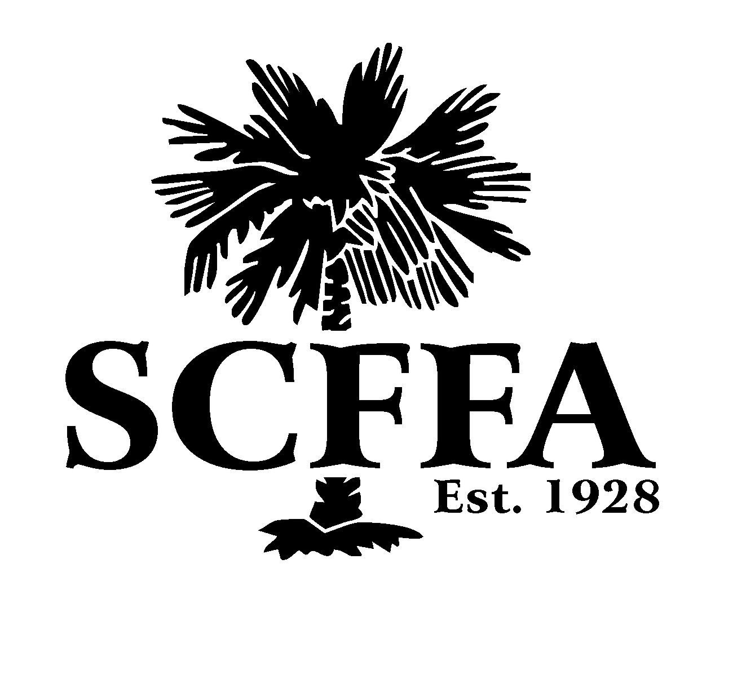FFA Advisor Handbook

The purpose of this handbook is to provide information to Agricultural Educators on the FFA programs that South Carolina has to offer as well as the history and organization of the FFA. Inspiration for the creation of this resource came from the needs of new teachers coming from industry, out-of-state, or those with limited FFA experience. Therefore, the following information is intended to be a reference for basic information as well as a guide for where to find additional assistance.

Table of Contents
South Carolina Agricultural Education Contacts…………………….……...3
Three-Circle Model………………………………………………….………….4
FFA History
South Carolina FFA History………………………………….…………5
Important National FFA Historical Dates………………….…………..6
Membership
Chartering a New FFA Program………………………….…………….7
Registering as a Chapter Leader………………………....…………....7
Affiliate Membership……………………………………….…………….8
Entering Membership through FFA.org………………….…………….9
Entering Membership through AET…………………………………...13
Membership Tips………………………………………………………..13
Middle School Members………………………………………………..14
Career Development Events & Leadership Development Events
South Carolina CDE’s & LDE’s………………………………………...15
Sample Scantron Sheets……………………………………………….17
How to Register for a CDE/LDE……………………………………….17
CDE/LDE Miscellaneous Tips………………………………………….18
FFA Events & Activities
Official Dress……………………………………………………………..19
South Carolina Workshops and Events……………………………….20
Applications
South Carolina Application Descriptions……………………………...26
Application Tips………………………………………………………….30
State Officers
State Officer Requirements…………………………………………….31
Requesting a State Officer……………………………………………..31
SC FFA Leadership Center
What to bring to Camp………………………………………………….32
Types of camping programs…………………………………………...33
SC FFA Constitution & Bylaws…………………………………………….34

South Carolina Agriculture Education Contacts

Troy Helms State Director of South Carolina Ag Ed
rthelms@clemson.edu
(803)-320-1064

Lee Petitgout Regional Coordinator: Regions 1 & 2/SC Farmer & Agribusiness
LPetitg@clemson.edu
(803)-374-6177

Mindy Sandifer Regional Coordinator Regions 3 & 4/FFA Leadership Center
MWest@clemson.edu (803)-300-2529

Jillian Lash SC FFA Executive Director
Jelash@clemson.edu
(803)-236-5542

Jason Gore FFA Program Assistant
Jdgore@clemson.edu
(843)-333-9712

Jennifer Lyda SC Ag Ed Administrator
SCAgEd@clemson.edu
(864)-656-8668

Ann Mayfield & Logan Layne SC FFA Leadership Center
SCFFACenter@gmail.com
(843) 249-6104

Three Circle Model
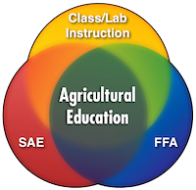
The mission of agriculture education is to prepare and support individuals for careers, build awareness, and develop leadership for the food, fiber, and natural resource systems.

Agriculture education combines Classroom Instruction, Supervised Agricultural Experience, and the FFA organization through integral instruction.

Classroom Instruction covers agriculture science and advanced sciences and gives students a practical approach to the theories of science and how they are used in agriculture, the largest science industry in the nation.

Supervised Agricultural Experience is the hands-on, work-based learning part of the model. It allows the students to learn industry skills through an ownership or non-ownership enterprise project that is overseen by their instructor.

The FFA organization is the training and testing area of agriculture education. FFA evaluates the skills that students learned through agriculture education by using Career Development Events. It also sharpens students’ speaking and leadership skills. The mission of the FFA is that the FFA makes a positive difference in the lives of students by developing their potential for premier leadership, personal growth, and career success through agricultural education.

South Carolina FFA History

The South Carolina Future Palmetto Farmers (FPF) was established at the summer teachers conference in July 1927 for the 1927-1928 school year.

The election of the first State Officers of the Future Palmetto Farmers was held at the State Fair in Columbia during the 3rd week of October 1927 The following students were selected as State Officers:
- President; Guy Whetstone of Wagener
- Vice President; Truex Padgett of Fairview School from Steedman
- Secretary Dudley Kell of Keowee School from Oconee County
- Treasurer Marion Gohagen of Furman

The first State Convention of the FPF was held at the State Fair in October
of 1927.

The FPF offered 3 student degrees: Green Hand, Palmetto Farmer, and Palmetto Planter. The Palmetto Planter was awarded by the State while the Green Hand and Palmetto Farmer were awarded by the chapter.

In November of 1928, a request for a National FFA Charter was submitted to allow the South Carolina Future Palmetto Farmers to become the South Carolina Future Farmers of America. At the time of the charter, there were 96 FPF chapters and 2,077 members.

The first State Officers of the South Carolina FFA Association for 1928-29 were:
- President James Jarret of Ninety Six
- Vice President Howard Barnhill of Gaffney
- Secretary Marion Edwards of Marion
- Treasurer Henry Daly Kleckley of Lexington
- Reporter Leon Hutto of Salley
- Advisor Mr. Verd Peterson of Columbia

Important National FFA Historical Dates

1914: Smith-Lever Act established the cooperative extension services

1917: Smith-Hughes Act created agriculture classes throughout the country

1928: Future Farmers of America (FFA) was founded in Kansas City, MO at the Baltimore Hotel

1929: National Blue & Corn Gold are adopted as the official colors

1930: The FFA Creed, written by E.M. Tiffany, was adopted

1933: The blue corduroy jacket was adopted as official dress

1935: New Farmers of America (NFA) was founded in Tuskegee, AL

1965: NFA and FFA merge

1969: Membership opened for female members

1973: Fred McClure, the first African American National Officer is elected

1976: Julie Smiley is the first female to be elected as a National Officer

1988: Future Farmers of America name changed to National FFA Organization

2003: Javier Moreno from Puerto Rico is the first person with a native language other than English and the first Puerto Rican elected as a National Officer

Chartering a New FFA Program

In order to become a chartered member of the South Carolina FFA Association, and maintain good standings within the association, the Agriculture Education program must have a certified agricultural educator as defined by the State Department of Education.

Contact Jillian Lash for information on chartering a new FFA program.

Registering as a Chapter Leader for Your FFA Program

Current SC FFA Advisor:
Email Jillian Lash with the chapter you were an advisor at and what school you will be moving to.

New South Carolina FFA Advisor:

Before registering as a chapter leader, you must first create an account with FFA.org

1. Log into ffa.org
2. Click on “Dashboard” and select “Teachers/Advisors”
3. On the left side of the screen, select “Request Access to a Chapter”
5. Complete the information on the page then select “submit” at the bottom of the screen
6. Once it is approved by Jillian Lash, you will have full access to your chapter’s information.

Affiliate Membership

Affiliate membership for high school and career technical programs allows all students enrolled in an agricultural program to be FFA members. There is a set fee based upon the number of students enrolled in the agriculture program.

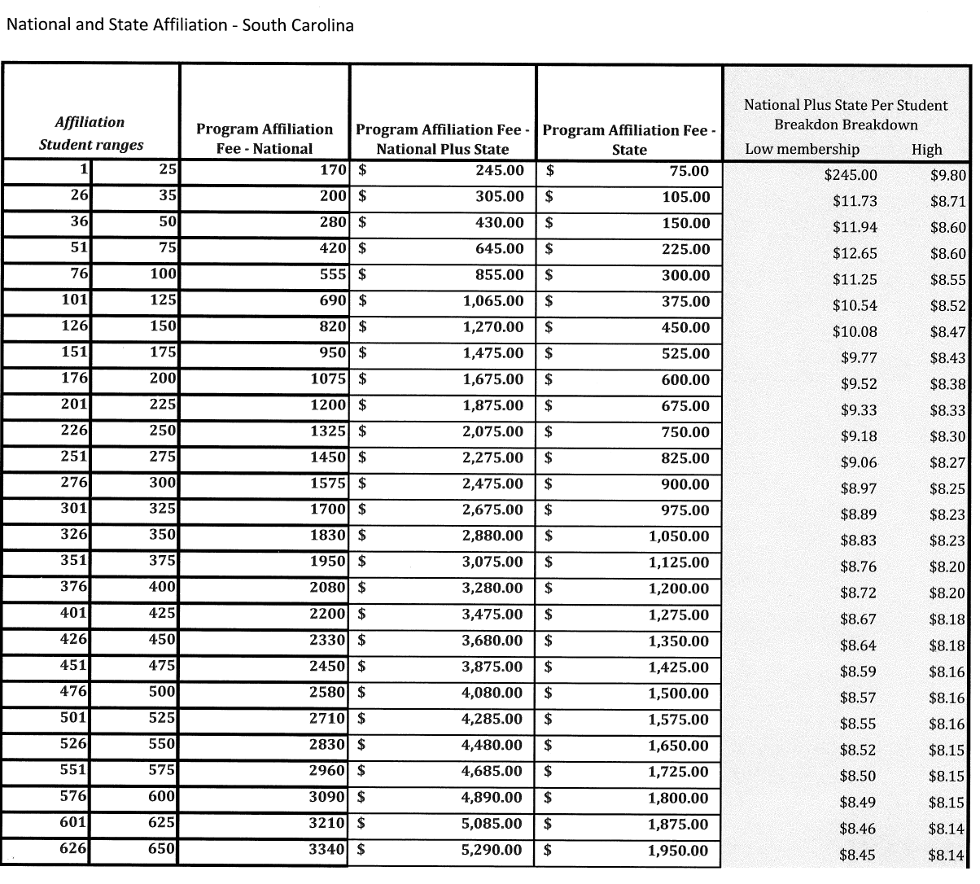

Middle School Flat Rate Fee Affiliate Membership: This affiliate allows all 6th & 8th grade students enrolled in agriculture education to become FFA members for a flat rate of $500.

For your chapter to be listed as an affiliate or Middle School Flat Rate Affiliate, you must first register on ffa.org.
- From the Teachers/Advisors Dashboard click Manage Chapter Profile
- Log in, if not already
- Program/Chapter Data tab > Dues/Fees tab
- Choose either “Affiliate” or “Middle School Flat Rate Fee”
- Click on Affiliation Request and read the policy.
- Click the box to acknowledge.
- Submit

Note: Any chapters considering or applying for affiliation should not locally approve their batch to state until after their request is state approved.

Entering Membership

There are two different ways to enter your chapter's FFA membership. Via AET or using ffa.org. Both methods are discussed in this section.

Using FFA.org
You can use the link on the SC Ag Ed website, under membership, or go directly to FFA.org.

Once you log into FFA.org, click on “Manage Roster”. It will take you to this screen:
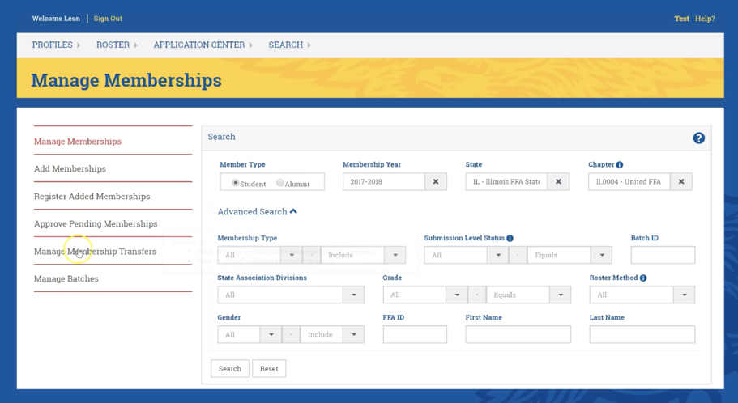

Manage Memberships: Search last year's roster to select FFA members who will be on this year's roster. Save to local.

Middle School programs: You can transfer former middle school members to the high school on this tab.
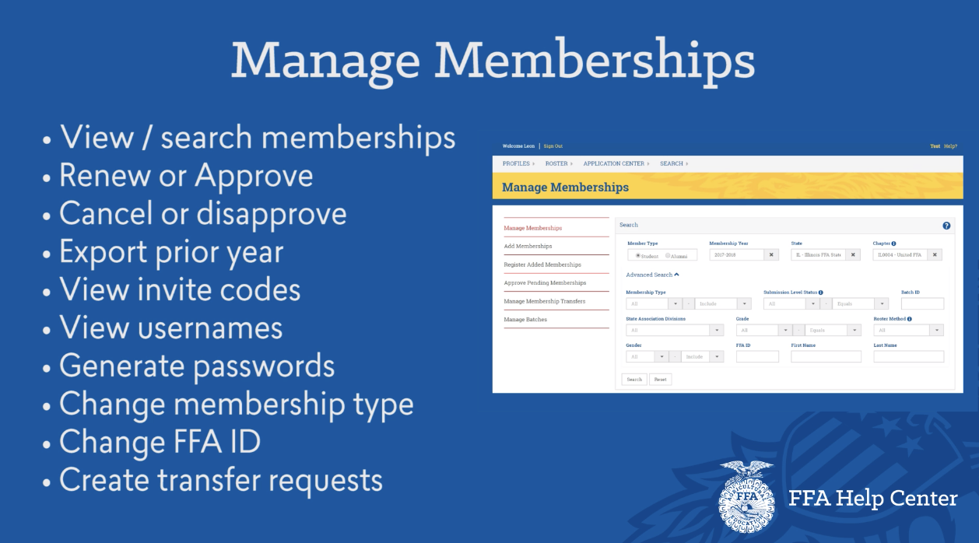

Add Membership: Add any new FFA members information here.
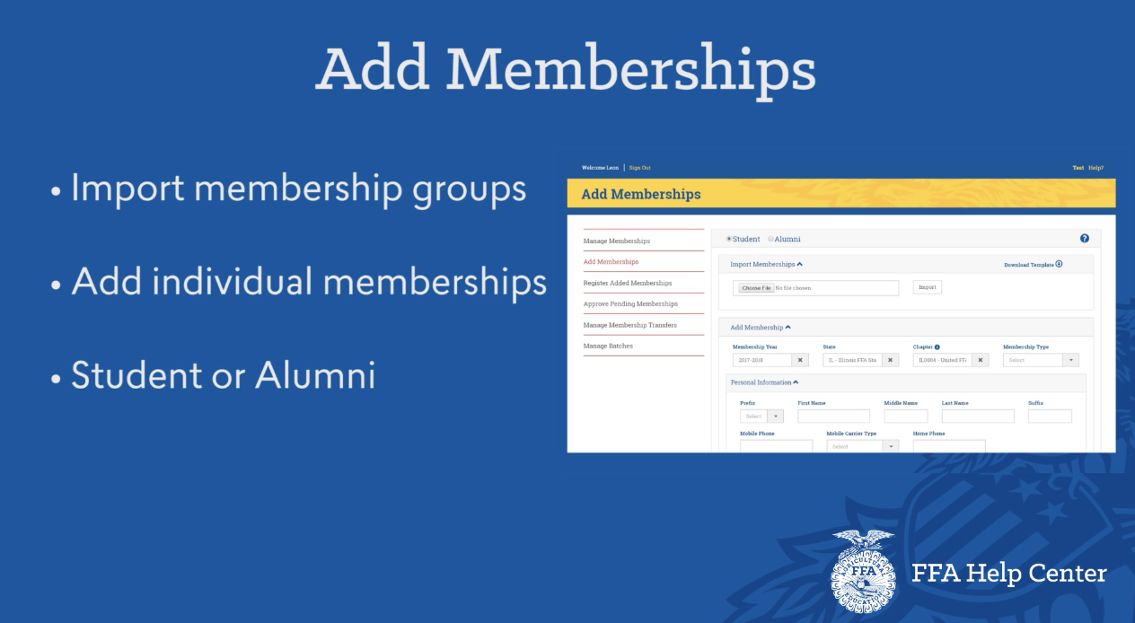
Register Added Memberships: Select newly added memberships. Save to local.
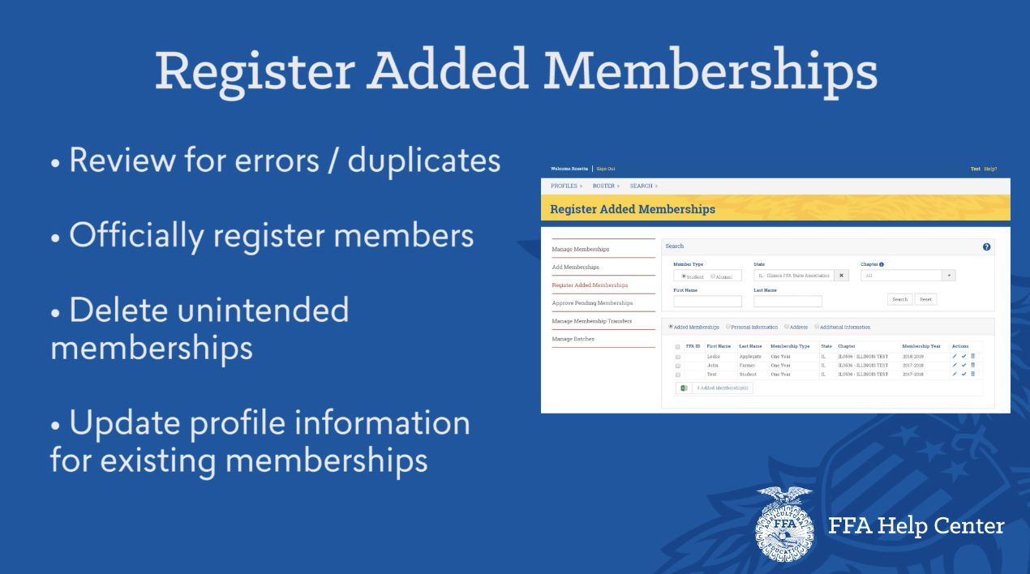

Approve Pending Memberships: Select all members that will be on your roster. Select “Submit to state”.
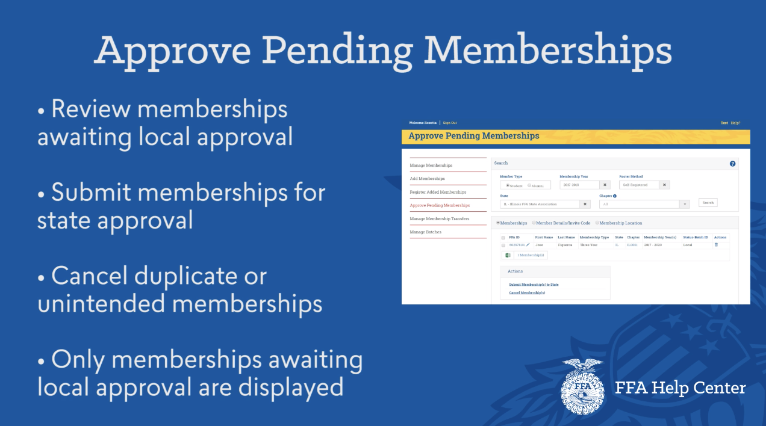

Manage Batches: PRINT YOUR INVOICE ON THIS PAGE!!!!
(This is for ALL FFA chapters, regardless of affiliation)

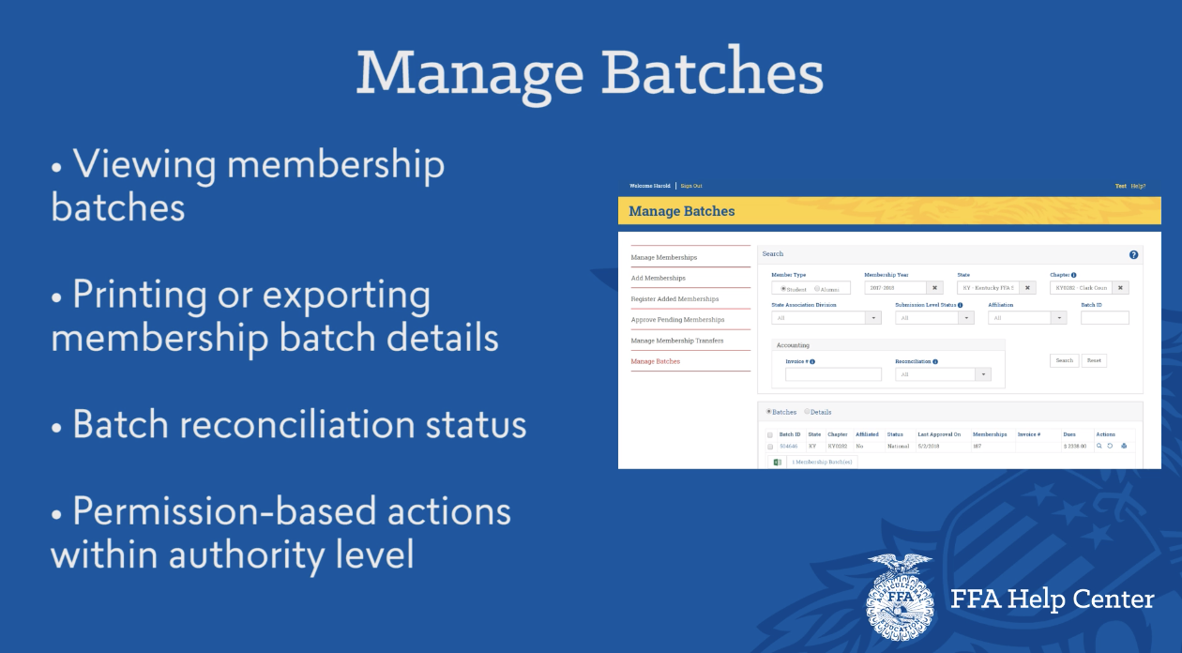

Completing FFA Membership Via AET.com
- Each student must complete 100% of their profile information required by FFA.
- On the Chapter page, under Accounts, select “FFA Roster Helper” (this will show you which students have or have not completed the required information).

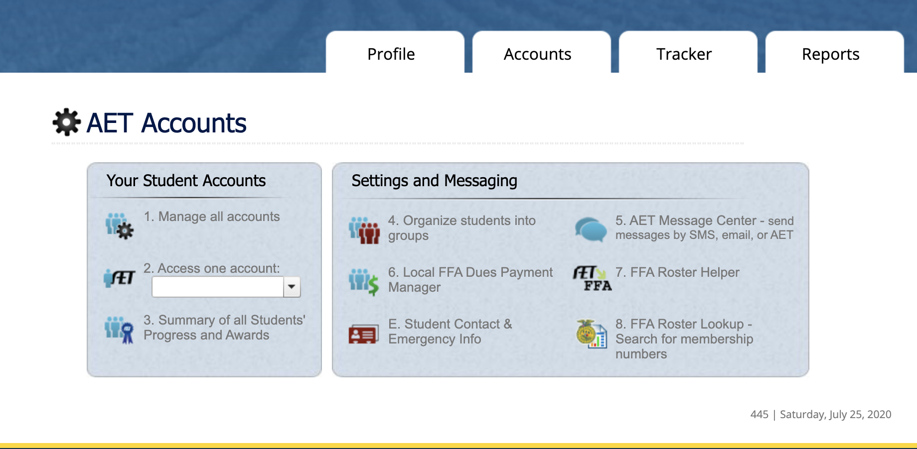

- From this page you can select all students or select specific students to be FFA members.
- Submit for membership.

Membership Tips
- National dues are $7 and State dues are $3.
- When all students are entered submit to State, not local. Cannot apply for State Degrees or scholarships without approved membership
- Print Membership invoice from FFA websites - do NOT wait for us to send you one. However, if you need an invoice email Jillian ASAP
- Cannot apply for scholarships, state degrees or any CDE/LDE at State Convention if dues are not paid in full.

Video link to assist with entering membership
https://help.ffa.org/articles/roster-system-tour-video/
Middle School FFA Membership

- FFA membership for middle school grades is available for those in 6th and 8th grade.
- What can middle school members participate in? 6th, 7th and 8th grade FFA members may participate in all activities, CDE’s and LDE’s that the South Carolina FFA Offers. The only exceptions are the Tractor Safety Operation CDE and AgMechanics CDE. Middle school FFA members can compete in CDE’s and LDE’s at the National Level.

Career & Leadership Development Events

South Carolina Career Developments Events (CDE) and Leadership Development Events (LDE) are competitions that develop college and career readiness skills, challenge FFA members to develop critical decision making skills, foster teamwork and promote communication. CDE’s and LDE’s are evaluated to make sure they align with State and National Standards.

South Carolina CDE’s & LDE’s
CDE/LDE | All Grade Levels | 1st Year Members | Region Competition | State Competition | National Competition
Agriculture Education | X |  |  | X
Agriculture Mechanics | X |  |  | X | X
Agronomy | X |  |  | X | X
Conduct of Chapter |  | X* |  | X | X
Dairy Evaluation | X |  |  | X | X
Dairy Handler | X |  |  | X | X
Employment Skills | X |  |  | X | X
Extemp. Public Speaking | X |  | X | X | X
Farm Business Management | X |  |  | X | X
Floriculture | X |  |  | X | X
Forestry | X |  |  | X | X
Greenhand Creed |  | X* | X | X | X
Greenhand Knowledge |  | X |  | X
Horse Evaluation | X |  |  | X | X
Livestock Evaluation | X |  |  | X | X
Meat Evaluation & Technology | X |  |  | X | X
Milk Quality & Products | X |  |  | X | X
Nursery & Landscape | X |  |  | X | X
Parliamentary Procedure | X |  |  | X | X
Poultry | X |  |  | X | X
Prepared Public Speaking | X |  | X | X | X
Soils | X |  | X | X | X
Tool ID |  | X | X | X
Tractor Operation & Safety | X* |  |  | X
Turfgrass Management | X |  |  | X
Vet Science | X |  |  | X | X
Upper  Creed |  |  | X | X
Wildlife | X |  |  | X
WHEP* | X |  |  | X | X

X* = Tractor and AgMechanics are not open to middle school FFA members
WHEP* = Wildlife Habitat Education Program
X* = Greenhand Creed & Conduct of Chapter are for 6-9 grade FFA members. They do not have to be a 1st year member.

CDE & LDE Resources:
- Resources for coaching a CDE or LDE can be found on the SC Ag Ed Website.
- On the top of the page, click on “FFA” then “CDE’s”.
- All resources can be found on the CDE Google Drive (link will be sent out and found at the bottom of Jason Gore’s email)

Sample Scantron Sheets:
- Familiarize your FFA members with the scantron sheets they will use for a CDE prior to attending the event.
- Scantrons can be found on scaged.org. Choose “FFA” then “Career Development Events”. “Judging Card Scantrons” is located at the bottom of CDE list (under WHEP)

How to register for a CDE/LDE:
You can register for CDE’s & LDE’s on the CDE Webpage (on scaged.org):

From the CDE page, choose either “Individual Event Registration”, “Team Event Registration” or “Agriscience Fair Registration”.

CDE/LDE Miscellaneous Items:

- All State winning CDE/LDE teams or individuals will receive a stipend to alleviate the cost of competing at the national level. If the chapter/individual cannot compete at the National level, they forfeit the funds and 2nd place will compete in their place.

- Some CDE’s/LDE’s require the use of items you will need to furnish, such as clipboards, calculators or other resources.

- Refer to the specific CDE/LDE for more information

- Registration: CDE/LDE registration is required one full week before the contest

- Any event using scantrons will have their scores on Judgingcard.com. All others will be emailed out

Official Dress
Official Dress is required for FFA members competing in Leadership Development Events, Legislative Appreciation Day, State Convention, National Convention, and many other events. FFA members must adhere to the proper official dress code as well as the code of ethics while wearing the jacket.

- Official FFA Jacket - zipped to the top
- White dress shirt
- FFA or plain navy-blue tie/scarf (No bow ties)
- Black dress pants or knee length black skirt
- Black socks/stockings
- Black dress shoes or dressy, clean black boots or black dress heels (low heel) or dress shoes (no buckles or bows)

While in Official Dress, it is unacceptable to wear:
- Hats
- Short Skirts (above the knees)
- Leggings
- Polo shirts

Official FFA Jackets are ordered by the advisor from ffa.org/shop. Measurements will be helpful in determining sizes and the size calculator is useful. Slightly larger is better than too small.

FFA members can apply or be nominated for a free Official FFA Jacket through the Gift of Blue program through National FFA on ffa.org and through the SC State Officer Gift of Blue on scaged.org.

SC FFA Workshops & Events

Chapter Officer Workshop (C.O.W.)

Who is it for? Your chapter officers. There is a limit of 10 attendees per chapter.

When is it? The workshop is held in September each year in conjunction with the SCAAE Fall teachers meeting.

Where is it held? The location will be held at an agriculture program within your region. The location will be decided at the SCAAE summer conference in July.

Is there a cost? Yes. There is a fee per Officer attending.

What is included in the cost? Each chapter officer will receive a t-shirt and the host chapter will provide a snack or meal.

How do I register? A registration link will be sent out via email

FFA Member Attire: Official dress or business casual.

FFA Day at the State Fair
Who is it for? All FFA members

When is it? Annually in October

What occurs during this event? A morning ceremony will be held on site at the State Fairgrounds (location will be announced prior to the event). The ceremony will begin with a welcome by the State Fair then four State Fair Scholarships will be awarded to one FFA member from each region. The ceremony will end with a chartering ceremony of any new FFA chapter (if applicable).
The State Tractor Safety Operations CDE will be held in conjunction with the FFA Day at the State Fair in the horse arena.

Where is it held? State Fairgrounds in Columbia.

Is there a cost? Admission is free for each FFA member, advisor, chaperone, and bus driver with a white FFA membership card. Membership cards can be found at https://ffa.app.box.com/v/FFA-Membership-Card-template

What is included in the cost? The FFA membership card will allow for free admission to the fair but does not cover food or rides.

How do I register? There is no registration for this event.

Advisor Attire: Casual while following your school district guidelines.

Student Attire: Casual while following your school district guidelines. If a student is receiving a scholarship or being recognized, then he/she must be in official dress during the ceremony.

National FFA Convention

Who is it for? All FFA members

When is it? Annually at the end of October

What occurs during this event? The National CDEs and LDEs will take place during the convention, and the SC FFA winners will compete during this time. A college and career expo will be held in the Indianapolis Convention Center. Workshops for students and advisors will take place in conjunction with the expo. National awards, scholarships, CDE, and LDE winners will be announced during the various sessions at the Lucas Oil Stadium. Chapters may also participate in multiple community service events held during the week (separate registration is required).

Where is it held? Indianapolis Convention Center and the Indiana State Fairgrounds, Indianapolis, IN.

Is there a cost? Chapters are responsible for hotel, registration, transportation and meal costs. Hotels in the state block will allow for a discounted registration. Instructions will be provided on how to purchase a bus or vehicle parking pass when registering.

State Hotel Block: Members of State Winning CDE/LDE teams, AgriScience and National Chapter Winners, along with other State Winners who will be competing or being recognized at the National Convention will have the first choice at obtaining housing in the State Block. If you do not have a winning team or application, you may still apply to get a room in the State Block. Availability will be determined on the first-come, first-served basis. The State Block application and deadlines will be posted immediately after the State Convention.

What is included in the cost? Convention registration includes sessions, workshops and the Expo.

Additional Costs: There is extra cost for parking, rodeo, concerts and some other events.

How do I register? See ffa.org for the registration information.

Advisor Attire: Professional attire and/or business casual attire (depending on the event you will be attending)

Student Attire: Official Dress while attending Convention activities.

Where do I find more information? FFA.org

SC FFA Legislators Appreciation Day

Who is it for? All FFA members

When is it? Annually during FFA Week.

What occurs during this event? FFA chapters can schedule to meet with their legislators and representatives to thank them for their support for Agriculture Education and the FFA. Beginning in the morning, a brief ceremony will be held on the State House Steps. The FFA Week Proclamation & Joint Resolution will be presented. Past guest speakers have included the Superintendent of Education and the Commissioner of Agriculture amongst others.

Where is it held? State Capitol, Columbia, SC.

Is there a cost? No Cost

How do I register? There is no registration fee for this event. However, you will need to schedule an appointment to meet with your Legislator at https://www.scstatehouse.gov/legislatorssearch.php

Advisor Attire: Professional Attire

Student Attire: Official Dress

Where do I find more information? Go to SCAgEd.org. Under FFA choose “Events” then “SC FFA Legislators Appreciation Day”.

SCAAE/SCFFA Plant Presentation of Flowers to the State House

Who is it for? All FFA members

When is it? Annually in April

What occurs during this event? We ask that each Agricultural Educator donate 3 flats of plants/flowers to this event. All flats will be donated to the State House Grounds to be planted. You may bring the flats to the Spring Teachers meeting. A teacher from your region will haul the plants to the State House if you are unable to attend the event.

In the morning of the event, a brief ceremony will be held to donate the plants to the State House Grounds and a few comments will be made. If you are unable to attend Legislative Day, this is another outstanding opportunity to have your FFA members meet with your legislators.

Where is it held? State House Steps, Columbia, SC

Is there a cost? There is no cost for this event

How do I register? You do not need to register for this event. If you would like to meet with your Legislator that morning you will need to schedule an appointment to meet with him/her. https://www.scstatehouse.gov/legislatorssearch.php

Advisor Attire: Professional Attire

Student Attire: Official Dress is preferred. If unavailable, then professional attire will be acceptable.

National and South Carolina FFA Applications

All applications can be found on the SC Ag Ed website.
- Click on “FFA” on the top of the page
- Choose “Applications”
- Select the application you are interested in

- State Fair Scholarship:
One FFA member from each region will be selected to receive a $500 scholarship. Winners will be notified prior to the State Fair and the scholarship will be awarded during the ceremony during the FFA Day at the State Fair.

The following applications are due at the SCAAE Spring Teachers Meeting

- National Chapter: National Chapter Form I is required for all teachers that are on a 12-month contract. This form highlights your chapters activities and accomplishments in the categories of growing leaders, community development and strengthening agriculture. You do not need an AET account to access the application.

- State Degree: Short Form: For members who are interested in earning their State Degree. See application for requirements.

- State Degree: Long Form: For members who are earning their State Degree for the first time and want to be considered for a SC Star applicant. See applications for requirements.

- SC Officers Gift of Blue: Each State Officer gives up a portion of their scholarship to purchase an FFA jacket for SC FFA members. 6 jackets will be given away each year.

- Honorary State Degree: Awarded to any administrator, teacher, community member of person who has provided the South Carolina FFA Association support.

- Honorary American Degree/Honorary American Teacher Degree: Individuals who have provided exceptional service on a national level to agriculture, agricultural education, or FFA are eligible for the Honorary American FFA Degree. Additionally, teachers who have created high-quality agricultural education programs which inspire and motivate their students to strive for success are eligible. Whoever nominates the person will complete the application process online.

- Individual FFA Award: The purpose of this award is to offer an incentive to students that are well rounded in their SAE, FFA Leadership, School and Community Activities, and Scholastic Ability. A region winner will be selected, and the State Winner will receive a $500 scholarship.

- SC Fertilizer and Agribusiness Association Scholarship: Two scholarships are awarded for students who are pursuing an agriculture major and career. One scholarship is awarded to a junior or senior attending Clemson while the other is awarded to someone who is attending a university in South Carolina that is not Clemson University.

- SC Farmer and Agribusiness Association Scholarship: The purpose of this scholarship is to offer assistance to students who have chosen to attend a college or technical school in order to prepare for a career in agriculture.

- SC Chapter of the Soil & Water Conservation Society Scholarship: $1,000 scholarship for FFA members pursuing a career in conservation/natural resources.

- National FFA Scholarships: National FFA Organization offers a wide variety of scholarships available for different majors. Refer to ffa.org. The information can be found under “Explore FFA” and “Awards and Competitive Events”.

- The Frank Stover Sr. Agricultural Education/FFA Scholarship: This scholarship was established in honor of the late Mr. Frank Stover, Sr. It is awarded to a Clemson University enrolled in Agriculture Education who plans on pursuing a career as an Agricultural Teacher in South Carolina.

- American Degree: This degree is the highest degree an FFA member can receive. Detailed requirements are listed on the National FFA website.

- Hilton V. Rogers Scholarship: Scholarship available to any incoming Freshman to Clemson University in an agriculture major.

- State FFA Officer Applications: FFA members must have received or will be receiving their State Degree at the State Convention in which they are applying to be a State Officer. (See State Officer Section for more information). Only one application per chapter is allowed.

- State Officers Nominating Committee: Open to any FFA member who is interested in serving on the State Nominating Committee to select the next year's State Officer Team. One person per chapter may apply and the student may run for a State Office position the following year. They will be required to attend the entire State Convention and arrive at the convention early.

- State Proficiency Awards: Proficiency awards are used to recognize students with outstanding SAE’s. The application should be submitted for students who have a few years of completing their SAE records.

- State Star Farmer: The FFA member will complete the long form of the State Degree. The FFA member must have an agricultural production SAE to apply. FFA members can only run for State Star once, and that is when they first apply for the State Degree.

- State Star in AgriBusiness: The FFA member will complete the long form of the State Degree. The FFA member must have a non-production SAE to apply. FFA members can only run for State Star once, and that is when they first apply for the State Degree.

- State Star Placement: The FFA member will complete the long form of the State Degree. The FFA member must have an agricultural placement SAE to apply. FFA members can only run for State Star once, and that is when they first apply for the State Degree.

Application Tips

Before Submitting:
- Start applications early and work on them over a period of time. Do not wait until the week before they are due to begin.
- Develop a Program of Activities (POA) in the summer. Use that POA to guide your program and use that information for your National Chapter application. POA examples can be found on the National FFA website.
- Put all applications in pronged folders or staple. Do not paperclip applications together.
- Not all applications will require a hard copy submitted. Review the directions of each application for the submission requirements.
- Check for the required signatures.
  - State Applications must be physically signed, South Carolina applications do not have “digital signatures”.
  - Nationals Applications (National Chapter, proficiencies) use a digital signature.
  - Photos:
    - Show variety in individual student applications (show growth over time)
    - If the FFA member is in the shop or using equipment, they are to have safety glasses and close-toed shoes.
    - Photos should show the FFA members' faces clearly.

State FFA Officers

In order to run for a State Officer position, your FFA member must:
- Have received or will be receiving their State Degree the year they run as a candidate.
- Be able to commit to a full year of service to the association while in school.
- FFA members can run for a state officer position until their second year out of high school.
- Only one FFA member per chapter may apply per year
- State Officers will be selected by a slate of their peers during the State FFA Convention.

Requesting a State FFA Officer for Your Chapter

To request a State Officer
- Go to the SC Ag Ed Website
- Click on FFA then “About” then “State Officers.”
- The link can be found at the top of the page.

Important: Teachers must stay in class the entire time (State Officers are not substitutes)

SC FFA Leadership Center (Camp)

Where to find information:
Go to the SC Ag Ed Website. On the top of the screen, choose “FFA Leadership Center”.

What forms do I need?
Refer to the “Camp Forms” tab for updated required forms.

What do we bring to camp?
(This is a general list. See camp website for additional details)
- Bedding for twin bed (sheets, blanket or sleeping bag and pillow)
- Towels (shower & beach)
- Toiletries (deodorant, shampoo, soap, toothpaste etc)
- Swimsuit
- Day/Camp Clothes (must adhere to camp rules)
- Tennis shoes
- Water shoes for activities at the marsh (no flip flops or Crocs allowed at the marsh)
- Change of clothes for evening activities
- Water/Water bottle
- Spending money (evening activities)
- Suggested Items: Snacks, cooler with drinks, frisbee, cards, books.

What type of camping programs are offered?
FFA Summer Camp:
Summer camp allows for FFA members to develop leadership skills and bond with other FFA members in their chapter and throughout the state. Activities include high ropes, kayaking, swimming, a beach trip and so much more.

Leadership Camp:
Similar to FFA Summer camp however the focus will be on leadership development activities. Interactive workshops will be presented by the State Officer Team. While any FFA members may attend, this camp is a great opportunity for your chapter officers to develop team building skills and meet with the State Officers.

Greenhand Camp:
Greenhand members will have the opportunity to participate in workshops, sports, team building, and leadership development activities presented by the current State FFA Officer Team. Members will compete in mock CDE’s to encourage participation upon returning to the chapter. Finally, Greenhands will also work in committees to plan and implement an FFA Banquet.

Specialty Camps:
Weekend long camps are offered in a variety of interest areas and career pathways. Examples include:
- Marine Fisheries Camp
- Equine Camp
- Outdoor Recreation Camp
- Forestry Camp
- Small Animal/Vet Tech Camp

SC FFA Constitution & Bylaws

The SC FFA Constitution and Bylaws can be found on the SC Ag Ed Website. Choose “FFA” then “About” on the top of the screen. On the drop-down menu, click on “Bylaws”.

