Please note that the State FFA Association will not pay for registration, housing and most meals for State Officer Candidates. We will make arrangements for them but the Candidate or chapter will make payment.

Advisors:
You may call or email if you have questions.

South Carolina FFA Association
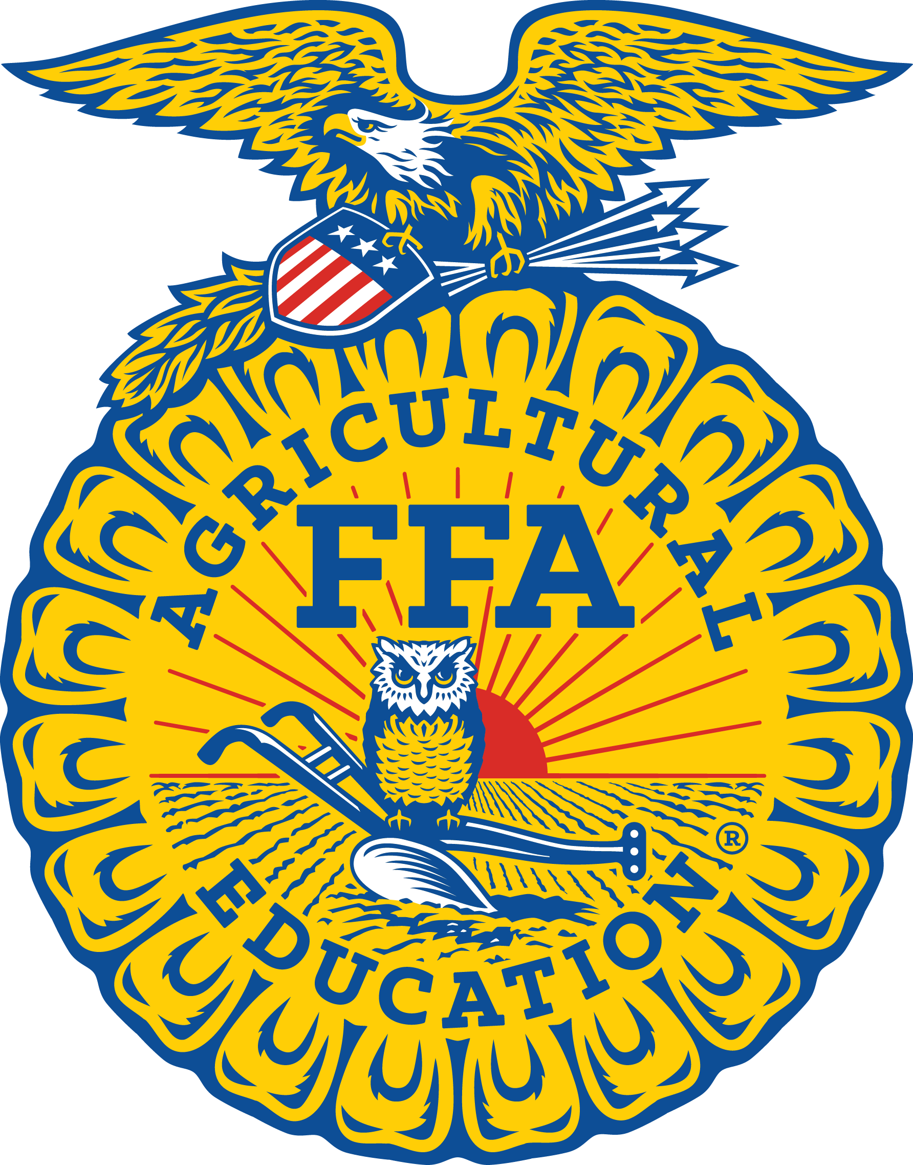
2024 State FFA Officer Application

Applications must be submitted by the Spring Regional Teacher Meeting

Applicant's Name: ________________________________________________________

Date of Birth: ______________

Applicant's Home Address: _____________________________________________________________

City/State: _____________________________ Zip Code: ___________________

Applicant's Home Telephone Number: _____________________________ Current Age: _________

Chapter Name: ________________________________ Agriculture Education Region: _____________

High School last Attended: ____________________________ Graduation Date: ________________

Number of Years in Agricultural Education? __________

Parent's/Guardian's Names: _____________________________________________________________

Will you be entering college next year? (Y/N) ____ If yes, where? _____________________________

What will be your major course of study? _________________________________________________

Polo Shirt Size (M/F cut):____ T-Shirt Size (Unisex):______.
Email Address: ________________________

Resume
Attach a one- or two-page resume' that includes the following sections:
a. Name/address/phone number/FFA chapter
b. Career objective
c. Education
d. FFA leadership activities /awards
e. School leadership activities/awards
f. Community leadership activities/awards
g. Professional associations
h. Other accomplishments
i. References
Attach an Official School transcript (Students will not see the transcript.)
State FFA Degree

All state FFA officer candidates must have the state degree or will be receiving the state degree this year.

The year you received or will be receiving. ______________

Questions (Attach responses)

- Briefly state what you feel to be the most important topic in agriculture today.

- Briefly state what you feel to be the most important topic in the FFA today. (State or National)

Essays

Write an essay about each of the topics listed below. Each essay must be typewritten, double space and on a separate sheet of paper. Each essay must not exceed one page.

- Describe your SAE Program.

- Describe your plans after high school.

- "Why I Desire to Serve as a State FFA Officer."

Please read, sign and return the "State FFA Officer Commitment Form" (page 3) with this application.
All of the above and enclosed information is true, correct and accurate to the best of my knowledge.

Applicant: __________________________________ Date: _______________

Parent: _____________________________________ Date: _______________

Administrator: _______________________________ Date: _______________

FFA Advisor: ________________________________ Date: ________________

South Carolina FFA
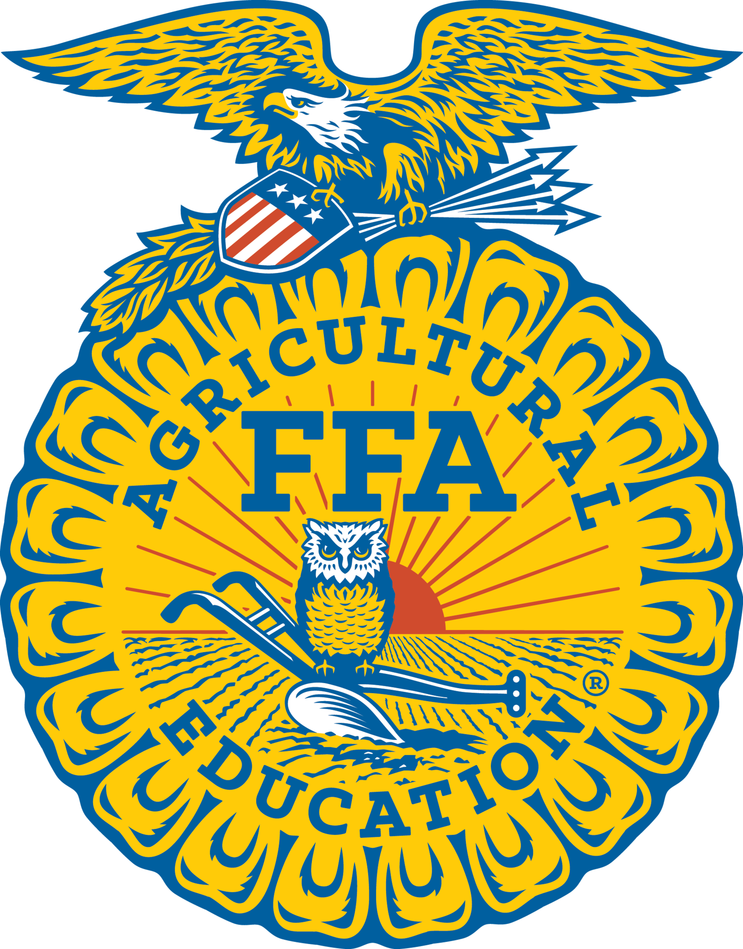
State Officer Commitment Form
(To be signed by each State FFA Officer Candidate and parent with the understanding that the State FFA Executive Secretary may remove a state officer from office, with the State FFA Advisory Committee approval, if the state officer does not satisfactorily follow these established standards.)

During my year of service, I pledge that I will:
- Be dedicated and committed to FFA and the total agricultural education program.
- Be willing and able to commit the entire year to State FFA officer activities.
- Be willing and able to travel, with transportation provide by the officer, as required in serving the South Carolina FFA Association.
- Become knowledgeable of agriculture, education in agriculture and agribusiness, and the FFA.
- Thoroughly prepare, practice and develop into an effective public speaker and project a desirable image of FFA at all times.
- Regularly, and on time, write all letters, thank you notes, reports and other correspondence that are necessary and desirable.
- Accept and search out constructive criticism and evaluation of my total performance.
- Keep up-to-date on current events.
- Maintain my personal health and appropriate grooming. (Males are to be clean-shaven and hair can not touch the collar of Official Jacket)
- Abstain from alcohol, tobacco and illegal substances during my year of service to the FFA.
- Treat all FFA members equally.
- Avoid places or activities that in any way could raise questions as to one's moral character or conduct.
- Consider FFA activities to be my primary responsibility.
- Use appropriate language in all speeches and informal conversations.
- Maintain proper dress and good grooming for all occasions.
- Work in harmony with fellow FFA officers, and not knowingly engage in conversations detrimental to other FFA members, officers or adults.
- Serve as a member of the team by maintaining a cooperative attitude.
- Be willing to take and follow instructions as directed by those responsible for state FFA officers and state Ag Ed programs.

Student Signature: ________________________________________ Date: __________

Parent/Guardian Signature: _________________________________ Date: __________

