Food Insecurity Resources
The following links are meant to serve as a resource for those who would like to participate in food security efforts across the Upstate.

Openfields Website: Openfields is a consulting firm that brings together specialists across disciplines to offer creative and strategic tools for innovation across sectors, specifically for complex social challenges.



SC Food Insecurity Risk Map (Food is Medicine SC): The SC Food Insecurity Risk Map was created to show counties in the highest risk areas for food security issues. The map also highlights demographic, health and community information.

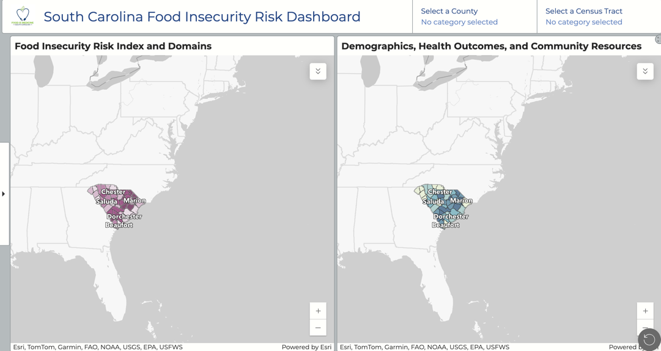

SC Food Insecurity Risk Map Story Board: Also from Food is Medicine SC, the Risk Map Story Board explains the decisions and data that can be gathered from the SC Food Insecurity Risk Map.

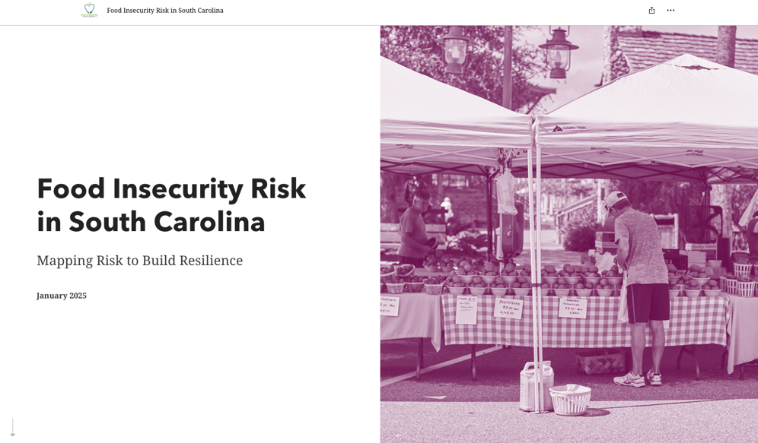

LiveWell: A food security coalition in Greenville, SC.

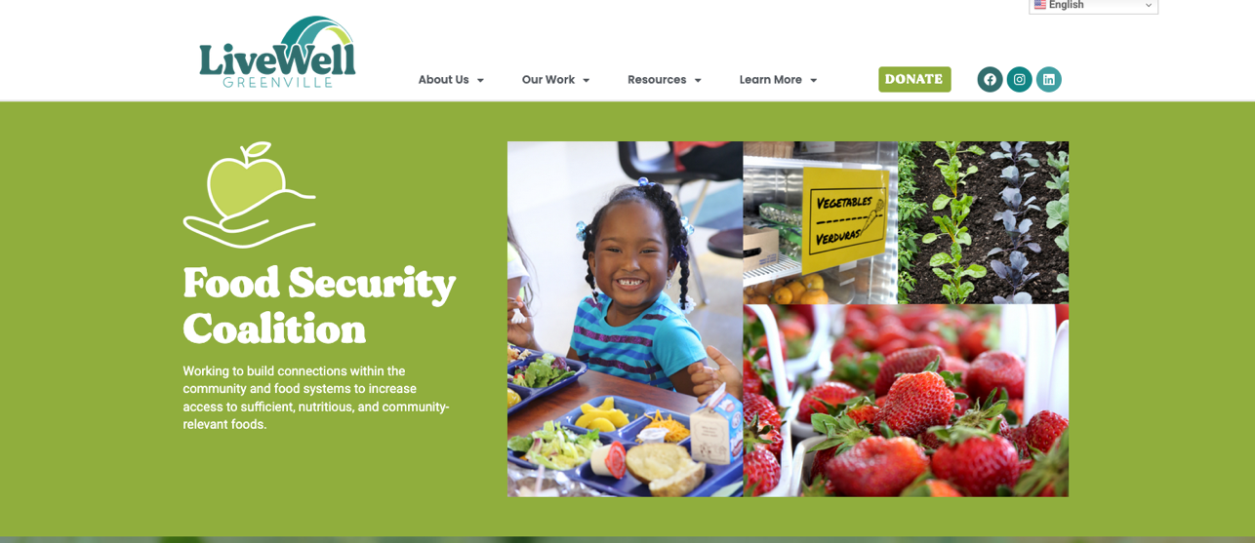

Clemson Rural Health: The organizing framework for Clemson’s health service delivery and prevention efforts statewide.

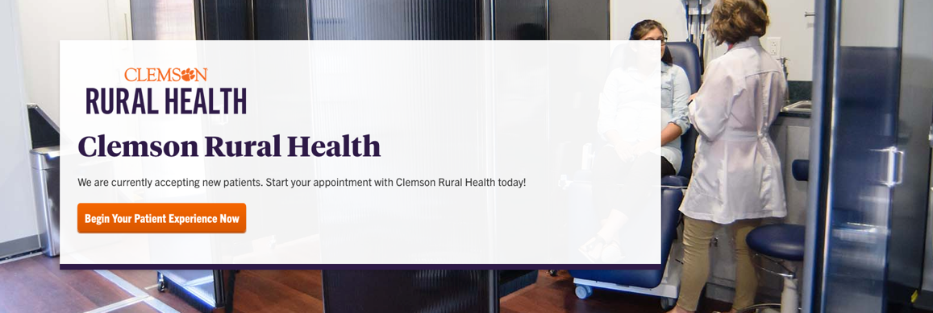

South Carolina Food Systems Network: A forum for members to share their concerns and progress on programs and initiatives that are related to the food systems in South Carolina.

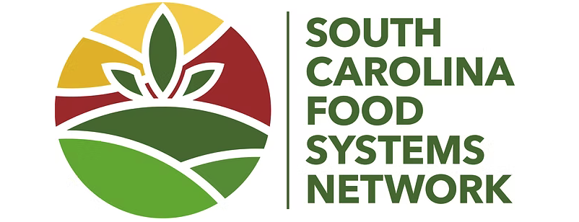

Department of Social Services Food and Nutrition Programs: A designated program area at DSS that focuses on increasing healthy habits by providing resources to acquire the necessary foods to maintain a healthy lifestyle.

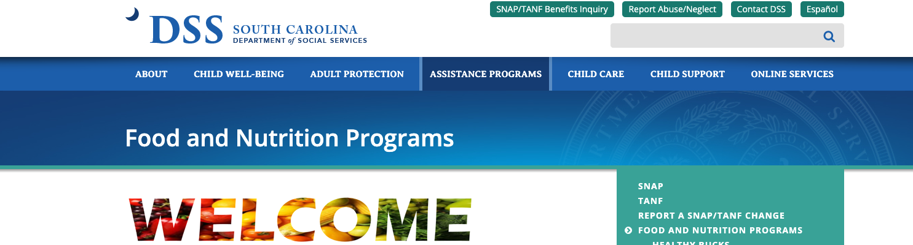

Clemson Paw Pantry: A community-wide movement to reduce food insecurity and promote wellbeing at Clemson. The Pantry is available to any current students with a valid CUID.

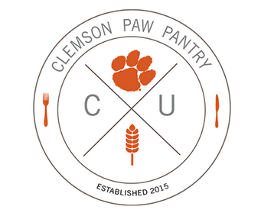

The Nook: An employee-focused pantry, designed to support faculty and staff who may be experiencing food insecurity or financial hardships.

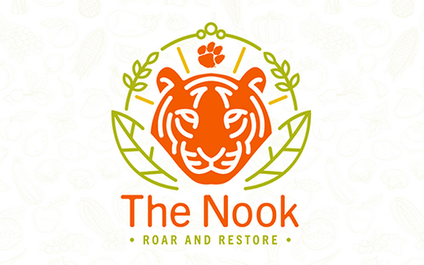

Clemson Community Care: An organization that works in cooperation with local religious, civic, educational, and private agencies to support low-income families and individuals by helping them overcome periods of financial crisis and become self-sufficient.

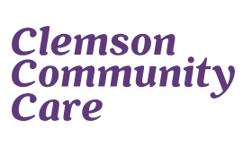

United Way of Pickens County: A worldwide nonprofit organization working to advance the common good by creating opportunities for a better life for all.



