

**Environmental Engineering**

**and Earth Sciences**

**EEES Department Seminar**

**Lab Safety Refresher**

PRESENTED BY

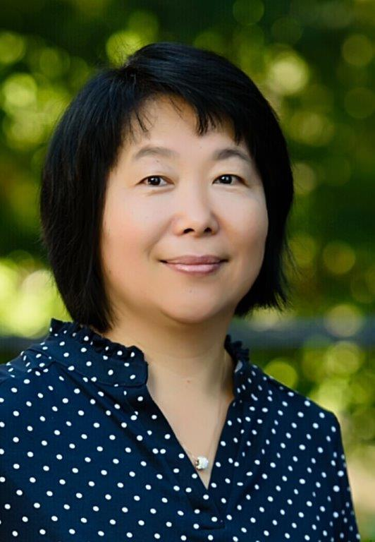

**Laura He, CSP, MS**

Health and Safety Specialist

Occupational and Environmental Safety

All are required to attend the Laboratory Safety Seminar which will be held on Friday, August 30 at 2:30 PM to 3:30 PM at the Rich Lab Auditorium. The training will be held by Laura He. She will cover topics concerning Safety Training Requirements, Workplace Hazards & Control Hierarchy, Chemical Safety, and Incident and Emergency Responses. We look forward to your attendance!

**2:30 PM**

**Friday, August 30, 2024**

***“Attendance is mandatory for graduate students enrolled in EES 8610, EES 9610, and GEOL 8610”***

