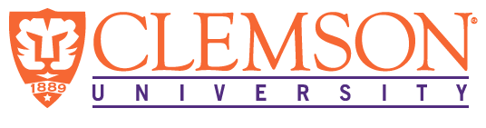

**Environmental Engineering**

**and Earth Sciences**

**EEES Department Seminar**

**Stories from Fukushima**

PRESENTED BY

**Nicole Martinez and Brian Powell**

Clemson University

Nagasaki University, in cooperation with local communities in the Fukushima prefecture, hosts an approximately yearly International Advanced Training Course (IATC) on stakeholder engagement. IATC was developed through the team’s decade-plus experience with recovery efforts following the 2011 nuclear accident at Fukushima Daiichi Nuclear Power Station (FDNPS). The IATC course is a multi-day, in person course involving both didactic and experiential components for a relatively small group of local university graduate students and international technical experts. The first portion of this presentation will describe course highlights from Dr. Martinez’s time as a Fall 2023 IATC participant and will largely focus on the human dimension of the accident and subsequent recovery. The final portion of this presentation will focus on technical aspects of the Advanced Liquid Processing System (ALPS) at FDNPS used to treat water prior to ocean release and will be delivered by Dr. Powell.

**2:30 PM**

**Friday, September 6, 2024**

***“Attendance is mandatory for graduate students enrolled in EES 8610, EES 9610, and GEOL 8610”***

