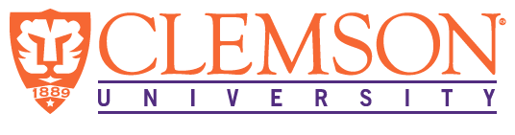

**Environmental Engineering**

**and Earth Sciences**

**EEES Department Seminar**

**With Liberty and (Environmental) Justice for All –**

**A Researcher’s Attempt at EJ in SC**

PRESENTED BY

**Lesley Joseph**

Molinaroli College of Engineering and Computing

University of South Carolina

**Bio:**

Dr. Lesley Joseph is currently a Faculty Fellow in the Department of Civil and Environmental Engineering at the University of South Carolina. His research focuses on environmental justice issues, with particular interest in water quality, waste management, and food systems. He received his BS, MS, and PhD from USC, along with a Master of Science in Environmental Engineering from Johns Hopkins University. Dr. Joseph is also a licensed professional engineer (PE) in South Carolina with over 10 years of experience in the design of water/wastewater conveyance and treatment plant projects, along with project management and construction inspection services.

**Abstract:**

The environmental justice (EJ) movement, both in the United States and around the world, has highlighted the disproportionate environmental burdens and hazards that have been placed on communities based on race, class, and gender. This movement, led by community leaders and activists, has worked to identify and minimize the impacts of harmful environmental activities, including hazardous waste dumping, air and water contamination, and overall poor environmental quality. This movement has also uncovered the lack of basic amenities and environmental benefits, including greenspace, resilient physical infrastructure, and healthy food access. However, in South Carolina, more environmental justice research is needed to understand the presence and impact of these disparities on the residents. This presentation aims to introduce various types of EJ research that can be done in South Carolina from the perspective of an environmental engineering researcher. Many EJ organizations and entities exist in South Carolina, and fundamental EJ research and analysis can support the great work that is done and provide healthy collaborative partnerships to fight for a more equitable and just society in the Palmetto State.

**2:30 PM**

**Rich Lab Auditorium**

**Friday, September 20, 2024**

***“Attendance is mandatory for graduate students enrolled in EES 8610, EES 9610, and GEOL 8610”***

