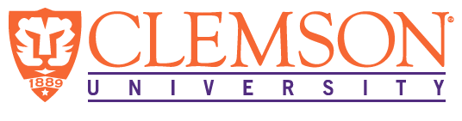

**Environmental Engineering**

**and Earth Sciences**

**EEES Department Seminar**

**Nuclear waste: what is it and where should we put it?**

PRESENTED BY

**Brian Powell**

Clemson University

Abstract: South Carolina gets around 40% of our power from nuclear energy and is also home to a nuclear fuel fabrication plant, a low-level nuclear waste disposal facility, and the United States Department of Energy Savannah River Site. Furthermore, many homes in the upstate have elevated levels of indoor radon due to the natural occurrence of uranium and radium in the underlying soils. Thus, radioisotopes are all around us and part of our everyday lives. In this discussion, we will cover the different types of radioactive waste and naturally occurring radioisotopes and discuss plans for the safe disposal of radioactive waste to minimize impacts on human and environmental health.

**12:00 PM**

**Monday, January 13, 2025**

**Rich Lab Auditorium**

***“Attendance is mandatory for graduate students enrolled in EES 8610, EES 9610, and GEOL 8610”***