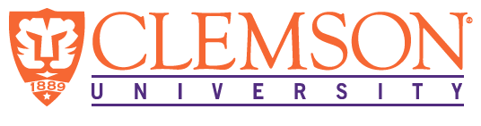

**Environmental Engineering**

**and Earth Sciences**

**EEES Department Seminar**

**Fundamental Mechanisms in Sustainable Materials from Global Environment to Climate Change**

PRESENTED BY

**Haiyan (Christina) Mao**

**Research Scientist**

**Department of Materials Science and Engineering**

**Stanford University**

**Abstract:**

In this seminar, I will describe the atomic-level design of sustainable and nanoporous materials, such as wood-derived nanomaterials, which are critical for the development of advanced technologies for carbon capture and air pollution remediation. The first part of the talk highlights the development of hierarchical nanoporous carbons and hierarchical nanopore-spaced membranes from woodchips using microwave-assisted conversion and controlled-pyrolysis methods. These materials exhibit tunable structures for efficient CO2 capture and organic compound adsorption. Advanced characterization techniques, such as multidimensional solid-state NMR, are employed to understand guest-framework interactions. The second part introduces a novel family of polyamine-appended solid-state networks capable of spontaneous CO2 chemisorption on a kilogram scale, offering high adsorption capacity, low cost, and energy-efficient regeneration. Dynamic combinatorial chemistry and 2D NMR techniques reveal the mechanisms behind these materials' performance. The third part outlines future research at Clemson University, emphasizing the atomic-level design of sustainable nanomaterials to tackle the most urgent needs at the greenhouse gas-energy-climate nexus.

**Bio:**

Dr. Haiyan Mao is a Research Scientist in the Department of Materials Science and Engineering at Stanford University. Her work spans the development of sustainable biomaterials (such as starch, shrimp shell, and cellulose), novel nanoporous materials (including polymers, metal-organic frameworks, and covalent organic frameworks), and advanced solid-state NMR spectroscopy. Her research aims to create energy-efficient, scalable solutions for CO₂ capture and reduction, ocean water pollutant remediation, and energy storage.

**12:00 PM**

**Monday, February 17, 2025**

**Rich Lab Auditorium**

***“Attendance is mandatory for graduate students enrolled in EES 8610, EES 9610, and GEOL 8610”***