

**Environmental Engineering**

**and Earth Sciences**

**EEES Department Seminar**

**Biosystems Engineering:**

**A Key Discipline for Redesigning the Water-Food-Energy Nexus**

PRESENTED BY

**Sergio I. Martinez-Monteagudo**

**New Mexico State**

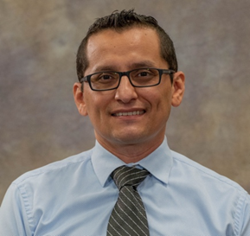

**Abstract:**

The modern food system is facing unprecedented challenges due to a rapidly growing global population, climate change, and the depletion of essential natural resources. These challenges threaten the sustainable production of food, highlighting the urgent need for innovative and collaborative approaches to address the complex relationships between water, food, and energy. In this context, my research group has focused on four key scenarios that are critical for ensuring a healthier, more sustainable food system – 1) engineering food quality, 2) upcycling byproducts and waste, 3) technological innovations, and 4) solubility studies. We will discuss the current outcomes of my research and explore the future directions for each area. We will discuss how we are developing a rheological fingerprint for frozen desserts to create novel structures that enhance both quality and sustainability. We will also explore our work on the one-pot synthesis of natural sweeteners from byproducts, a process that potentially enhances sustainability and reduces waste. Additionally, we will cover our technological innovation, Guided-Ultrasound-Enhanced-Evaporation, which aims to reduce energy consumption during evaporation. Lastly, we will delve into the study of chelator solubility under supercritical conditions to improve the extraction of rare earth elements. Join us as we look to the future of food production and explore possible solutions that could shape the next generation of food systems.

**Bio:**

Dr. Martinez-Monteagudo is an Associate Professor with a split appointment in the Departments of Family and Consumer Sciences and Chemical & Materials Engineering at NMSU. His position also supports the Center of Excellence in Sustainable Food and Agricultural Systems. Throughout his career, Dr. Sergio has published 55 peer-reviewed articles, 14 book chapters, 3 invention disclosures, and over 100 abstracts. Additionally, he has secured more than $6.6M from 21 grants awarded by various agencies and private industry. Dr. Sergio is the Editor-in-Chief of the International Journal of Food Properties.

**12:00 PM**

**Monday, February 24, 2025**

**Rich Lab Auditorium**

***“Attendance is mandatory for graduate students enrolled in EES 8610, EES 9610, and GEOL 8610”***