

**Environmental Engineering**

**and Earth Sciences**

**EEES Department Seminar**

**Microbial Resource Management in**

**Biosystem Engineering and Ecosystem Services**

PRESENTED BY

**Dr. Ramesh Goel**

Professor of Civil & Environmental Engineering

University of Utah

**Abstract:**

Biosystem engineering includes many branches of engineering, including electrical, environmental, agricultural, and mechanical engineering. Microbiology is the scientific study of microorganisms, encompassing research on the biochemistry, physiology, cell biology, ecology, and evolution of microorganisms, and is central to Biosystem Engineering. With microbiology at the center, Biosystem Engineering has positively affected the production of biomaterials, biofuels, medicine, and novel enzymes. Microbial resource management has evolved as an exciting opportunity to optimize the system performance and to understand better the ecological attributes under the broader theme of Biosystem Engineering. Microbial resource management allows us to understand the ecophysiology of microbial consortia and helps us understand synergistic functioning among microbes. Dr. Goel’s lab uses microbial resource management, which employs ecological theory and advanced bioinformatics, to study microbial community interactions in engineered bioreactors, natural ecosystems, and agricultural settings. In this presentation, Dr. Goel will present his research on microbial resource management with specific examples. Dr. Goel’s research uses advanced microbiological and bioinformatic tools to address 21st-century social challenges related to freshwater availability, human health, food, and energy. Beyond research, Dr. Goel is committed to integrating teaching and mentoring to cultivate the next generation of scientists and engineers in Biosystems Engineering. This talk will cover his research accomplishments, future research directions, potential teaching contributions, and their alignment with Clemson University’s Biosystem Engineering Program.

**Bio:**

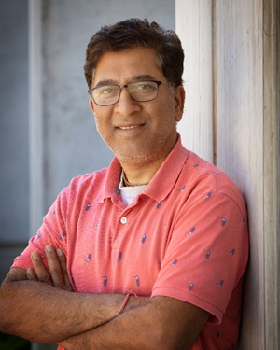Dr. Ramesh Goel is a Professor of Environmental Engineering and the Chair of the Faculty mentoring committee in the Department of Civil & Environmental Engineering at the University of Utah. He researches the interface of process engineering, ecosystem sustainability, and microbiology, focusing on bioenergy recovery from recalcitrant agricultural biomass, ecological theory principles, resource recovery from waste, carbon and energy efficient waste treatment, harmful algal blooms, virology, and computer bioinformatics. The United States National Science Foundation, USEPA, the US Department of Defense, the US Department of Interior, several local agencies, and water quality boards fund his research. Dr. Goel has published over 100 journal papers, including Nature Communications, Environmental Science and Technology, Water Research, Bioresource Technology, Environmental Pollution, Chemosphere, Science of the Total Environment,Scientific Reports, and more. He is the associate editor of the Environmental Engineering Science Journal, Chemosphere, Bioresource Technology, and Journal of Hazardous Materials Letters. He also serves as an editorial board member of several journals of international repute.

**12:00 PM**

**Monday, March 10, 2025**

**Rich Lab Auditorium**

***Attendance is highly recommended and encouraged.***