# Asparagus

In fall of 2023, Extension Agents throughout South Carolina surveyed growers on specialty crop acreage for the year. The goal was to identify the counties of production, acreage, and observable market prices for the year.

Total Number of Farms: **22**

Total Number of Counties: **17**

Total Acreage: **418.01**

Highest Acreage: **Calhoun County**

Organic Acreage: **70**

Processing Acreage: **300.5**

## Estimated Value:

Observed Prices: $26.00 - $31.00 per 11 lb. carton

Estimated Yield: 3,600 lbs. per acre (327 cartons)

Total Yield: 418.01 x 327 cartons per acre

x $27.85 per carton = $3,806,796 total value

|  |  |
| --- | --- |
| **County** | **Acreage** |
| Abbeville* | 1.0 |
| Aiken | 82 |
| Allendale | 4.0 |
| Calhoun | 300.0 |
| Charleston | 3.0 |
| Cherokee* | 1.0 |
| Chester* | 1.0 |
| Dorchester | 1.5 |
| Edgefield | 12.0 |
| Greenville* | 1.0 |
| Greenwood* | 1.0 |
| Laurens* | 1.0 |
| McCormick* | 1.0 |
| Pickens | 0.5 |
| Spartanburg* | 1.0 |
| Union* | 1.0 |
| York* | 6.0 |

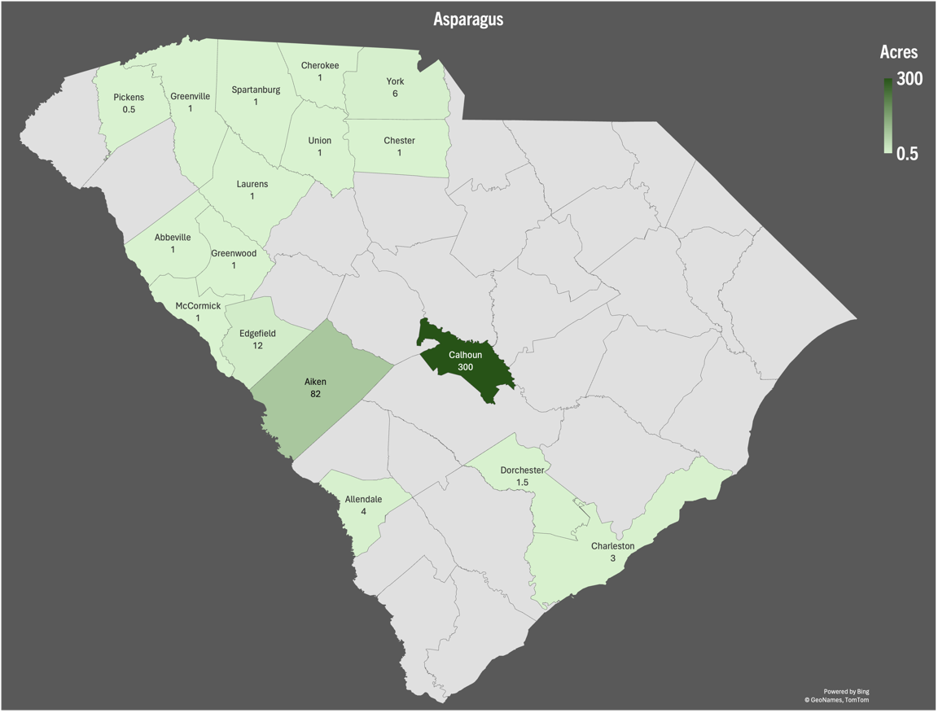

Figure 1: Cumulative acres per county

* = Data retrieved from USDA or FSA.  
If you are aware of missing acreage, please contact your   
[local horticulture extension agent](https://www.clemson.edu/extension/horticulture/team.html) or email [kburke5@clemson.edu](mailto:kburke5@clemson.edu).

This is a collaborative project between Clemson Extension [Horticulture](https://www.clemson.edu/extension/horticulture/index.html) and [Agribusiness](https://www.clemson.edu/extension/agribusiness/index.html) teams.