# Radishes

In fall of 2023, Extension Agents throughout South Carolina surveyed growers on specialty crop acreage for the year. The goal was to identify the counties of production, acreage, and observable market prices for the year.

Total Number of Farms: **22**

Total Number of Counties: **18**

Total Acreage: **11.73**

Highest Acreage: **Charleston County**

Organic Acreage: **0.2**

Processing Acreage: **0**

## Estimated Value:

Observed Prices: $20.00 per crate (12 lb.)

Estimated Yield: 15,000 lbs. per acre

Total Yield: 11.73 x 15,000 lbs.

x $1.67 per lb. = $293,836.5 total value

|  |  |
| --- | --- |
| **County** | **Acreage** |
| Abbeville* | 1 |
| Anderson | 0.25 |
| Beaufort | 0.3 |
| Charleston | 5.45 |
| Cherokee* | 1 |
| Chester* | 1 |
| Dorchester | 0.25 |
| Florence | 3 |
| Greenville* | 1 |
| Greenwood* | 1 |
| Kershaw | 0.13 |
| Laurens* | 1 |
| Lexington | 0.1 |
| McCormick* | 1 |
| Orangeburg | 0.25 |
| Spartanburg* | 1 |
| Union* | 1 |
| York* | 1 |

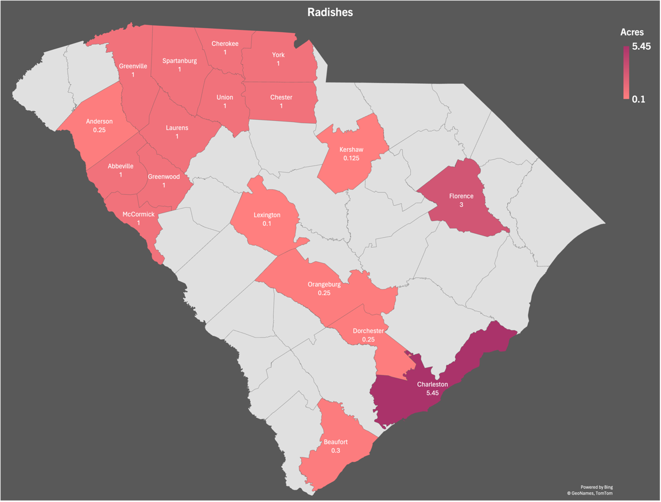

Figure 1: Cumulative acres per county

* = Data retrieved from USDA or FSA.  
If you are aware of missing acreage, please contact your   
[local horticulture extension agent](https://www.clemson.edu/extension/horticulture/team.html) or email [kburke5@clemson.edu](mailto:kburke5@clemson.edu).

This is a collaborative project between Clemson Extension [Horticulture](https://www.clemson.edu/extension/horticulture/index.html) and [Agribusiness](https://www.clemson.edu/extension/agribusiness/index.html) teams.