**2024 ANNUAL REPORT**

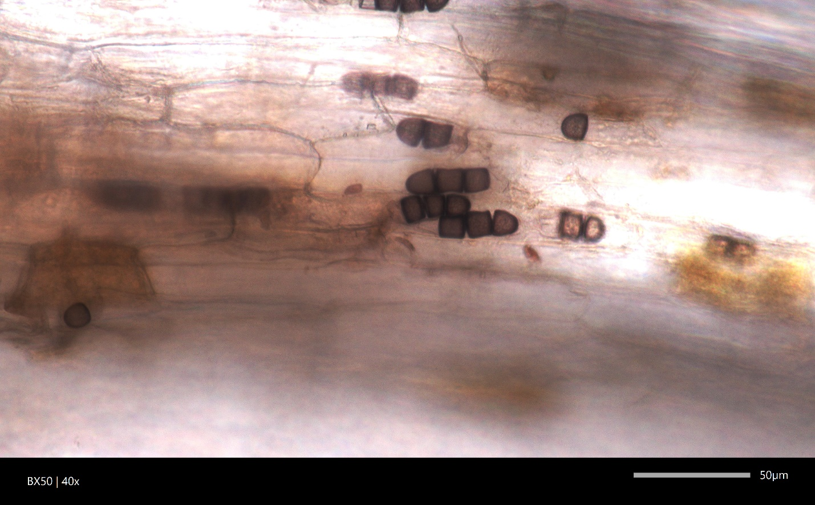

The cover page image shows chlamydospores of *Berkeleyomyces rouxiae*, a fungal pathogen causing black root rot on multiple milkweed species in SC, USA. See the publication at <https://doi.org/10.1094/PHP-11-23-0101-SC>.

The information contained in this report is based on work that was partly supported by the National Plant Diagnostic Network (NPDN). NPDN is a consortium of plant diagnostic labs across all 50 U.S. states and several territories. It is supported by the U.S. Department of Agriculture, National Institute of Food and Agriculture (USDA NIFA). We also thank NC Strawberry Association and USDA NIFA Crop Protection and Pest Management program, which provided grant funding to support our internship program.

***A message from Department of Plant Industry Labs staff***

As a part of Clemson University’s Regulatory Services Division, the Department of Plant Industry Laboratories (DPI Labs) is a unique program serving stakeholders in SC and clients in other states by providing high-quality diagnostic services such as plant health analysis, pest identification, plant identification, nematode assay, fungicide-resistance profiling, and molecular identification and rapid detection services. The DPI Labs program includes Plant and Pest Diagnostic Clinic (PPDC), the state lab dedicated to handle all plant diagnostic samples in SC, the Molecular Pathogen and Pest Detection (MPPD) Laboratory, the lab providing a variety of specialty services using advanced molecular techniques, the Commercial Turfgrass Clinic (CTC), a specialty lab providing expedited, high-quality diagnostic services of turf problems to golf courses, athletic fields, sod farms, and other turf management professionals, and the Nematode Assay Lab (NAL), a specialty lab identifying plant parasitic nematodes and assessing their risks. Our program also partners with other programs at the Clemson Regulatory Services, as well as Clemson Extension, teaching, and research communities to document new diseases and pests in SC and provide educational, research, and training opportunities.

Jordan Withycombe joined PPDC in March 2024 as a Lab Technologist II. She is primarily responsible for performing plant diagnoses. She has also been serving as our internship and outreach coordinator and assisting the Manager in planning outreach activities and hiring and mentoring student interns.

We thank our dedicated student interns in 2024.

**Graduate Research Assistant**

* Amanda Minner (Department of Genetics and Biochemistry)

**Undergraduate Diagnostic Assistant**

* Tabitha Williams (Horticulture Major, Department of Plant and Environmental Sciences – PES)
* Amber Fox (Wildlife and Fisheries Biology Major)

We thank faculty members, specialists, agents, and retired professionals who provided diagnostic and professional consultation in 2024. The Annual DPI Labs Advisory Committee Meeting took place on December 11, 2024. A special thanks to our Advisory Committee members who attended the meeting and provided suggestions and ideas that are paramount for improving our services.

**Advisory Committee Members**

* Dr. Shannon Alford (Director, Agricultural Service Laboratory, Regulatory Services)
* Allison Guggenheimer Bower (Outreach Coordinator, Regulatory Services)
* Millie Davenport (Director, Home and Garden Information Center, Clemson Extension)
* Dr. Timothy Drake, Jr. (State Entomologist, Assistant Director, Regulatory Services)
* Dr. John Hains (Associate Professor Emeritus)
* Matt Howle (Manager and State Survey Coordinator, Invasive Species Program, DPI)
* Dr. Steven Jeffers (Professor of Plant Pathology – Ornamental Crops & Trees, PES)
* Dr. Julia Kerrigan (Associate Professor of Mycology, PES)
* Dr. Haiying Liang (Associate Professor, Department of Genetics and Biochemistry)
* Steven Long (Assistant Director, State Plant Regulatory Official, DPI)
* Dr. Joseph Roberts (Associate Professor of Turfgrass Pathology and Nematology, PES)
* S. Cory Tanner (Director, Horticulture Program Team, Clemson Extension)
* Dr. Hehe Wang (Assistant Professor of Plant Bacteriology, PES)
* Dr. Ted Whitwell (Professor Emeritus)
* Meg Williamson (Educational Plant Diagnostician, DPI)

**Other Advisory Consultants in 2024**

* Justin Ballew (Fruit and Vegetable Research Associate, Horticulture Program Team)
* Dr. Lance Beecher (Aquaponics, Aquaculture and Fisheries Specialist, Clemson Extension)
* Dr. Eric Benson (Professor, Extension Entomologist, PES)
* Dr. Tom Bilbo (Assistant Professor of Vegetable & Strawberry Entomology, PES)
* Dr. Juang Chong (Adjunct Professor of Entomology, PES)
* Dr. Elizabeth (Libby) Cieniewicz (Assistant Professor of Plant Virology, PES)
* Dr. Lorena Endara (Herbarium Curator, Lecturer, Department of Biological Sciences)
* Dr. W. Cory Heaton (Assistant Director, Extension Wildlife Specialist, Clemson Extension)
* Dr. Anthony Keinath (Professor, Vegetable Pathologist, PES)
* Dr. Churamani Khanal (Assistant Professor of Plant Nematology, PES)
* Dr. Lambert (Bert) McCarty (Professor of Turfgrass Science & Management, PES)
* Dr. Guido Schnabel (Professor of Plant Pathology – Fruit Crops, PES)
* Dr. Joey Williamson (Retired Clemson Extension Horticulture Agent)

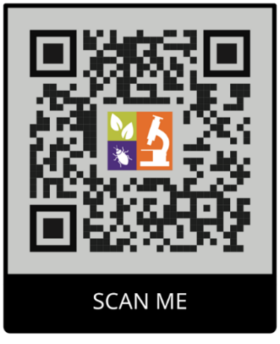DPI Labs’ seven staff members participated in over 95 training, outreach, educational, and service promotional events, such as two Clemson career fairs, a master gardener conference, Extension field days and in-service trainings, and the production of [a promotional video](https://youtu.be/S-dsntnf6ek?si=FWkG2Zd6SrLqKgt6) for our strawberry-focused services. Notably, we provided seven lab tours in 2024. The attendees included 44 students and five staff and 11 faculty members. We welcome old and new friends to tour our labs in the future! The Labs’ online social media have been posting on a weekly basis. Please scan the QR code on the right to visit our social media.

**DPI Labs Staff Members**



**Table of Contents**

***A message from Department of Plant Industry Labs staff*** 2

***Plant and Pest Diagnostic Clinic (PPDC) Report*** 5

**Fig. 1** Number of samples processed at PPDC by year over the past five years 5

**Fig. 2** Number of samples processed at PPDC by month in 2024. 5

**Fig. 3** Percentage of samples by source at PPDC in 2024 6

**Fig. 4** PPDC sample counts by client type in 2024 6

**Fig. 5** PPDC sample counts by sample category in 2024 7

**Fig. 6** Count of PPDC samples in 2024 by county in SC 7

***Molecular Pathogen and Pest Detection (MPPD) Lab Report*** 8

**Table 1** Sample count by category at the MPPD Lab in 2024 8

***Commercial Turfgrass Clinic (CTC) Report*** 9

**Table 2** Diagnostic results at CTC in 2024 9

***Nematode Assay Lab (NAL) Report*** 10

**Fig. 7** Number of samples received at NAL by month in 2024 10

**Fig. 8** Count and Percentage of samples by source at NAL in 2024 10

**Fig. 9** Count of NAL samples by SC county in 2024 11

***Plant and Pest Diagnostic Clinic (PPDC) Report***

A total of 1283 samples were received and processed at PPDC in 2024, an increase of approximately 6% compared to 2023 (**Fig. 1**). At least 130 samples were received in each month between May and September (**Fig. 2**).

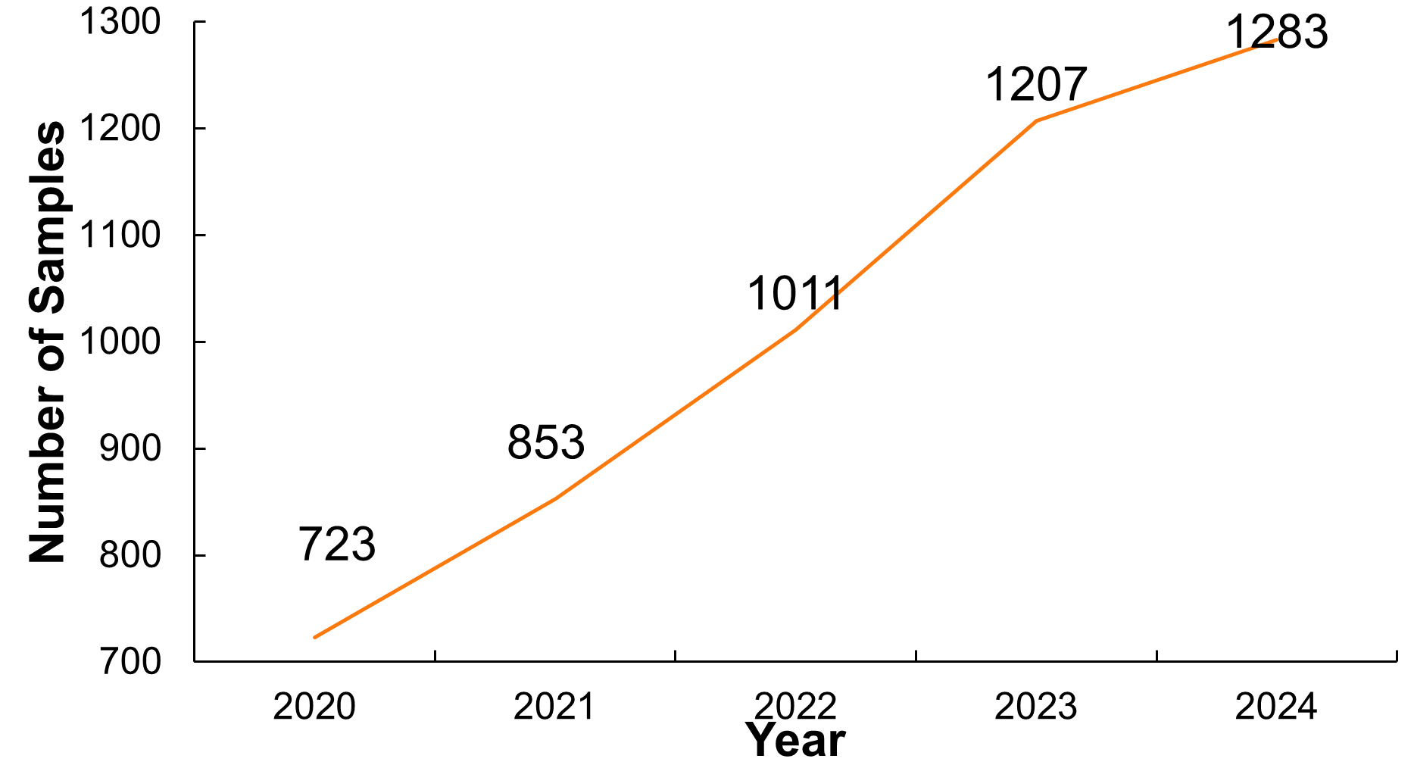

**Fig. 1** Number of samples processed at PPDC by year over the past five years

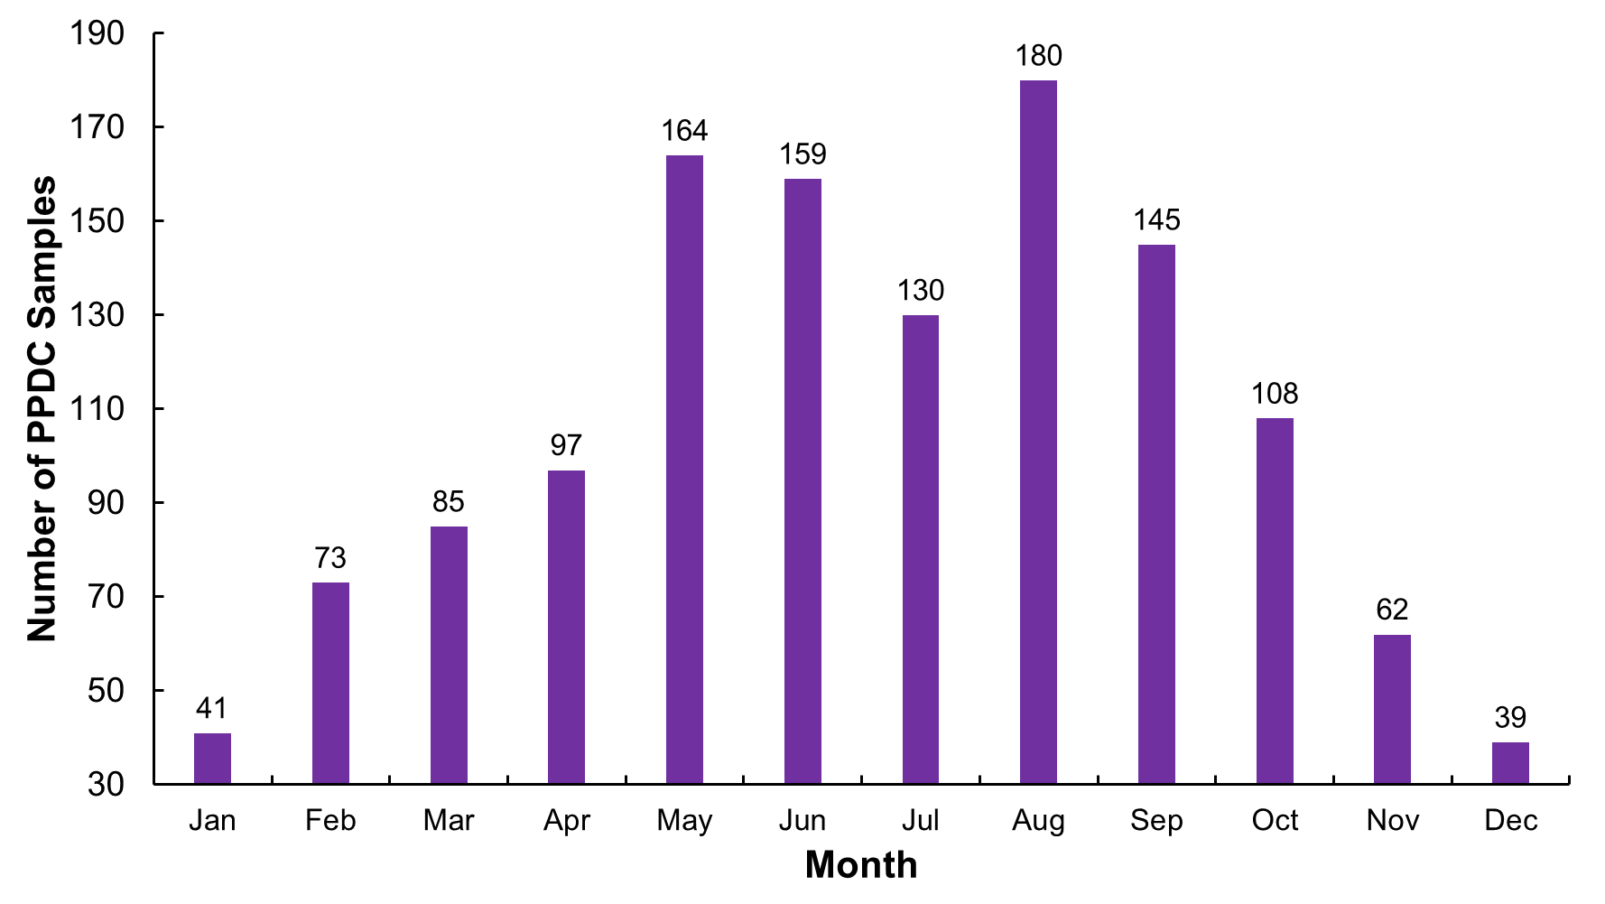

**Fig. 2** Number of samples processed at PPDC by month in 2024.

A total of 789 PPDC samples in 2024 were received from county Extension offices. A total of 601 samples originated from residential sites, while 680 samples were submitted by commercial clients (**Fig. 3**). We provided services to a total of 1878 clients of PPDC in 2024. Most of our clients (approximately 68%) were homeowners, home gardeners, other residential clients referred by Extension agents, and farmers. (**Fig. 4**).

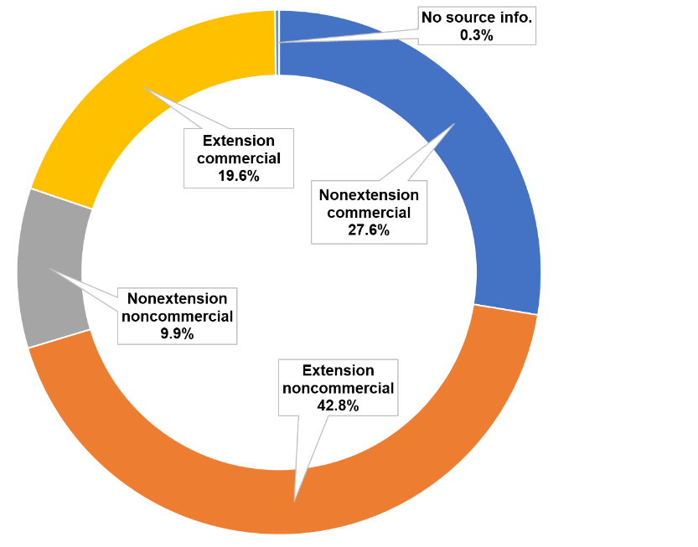

**Fig. 3** Percentage of samples by source at PPDC in 2024

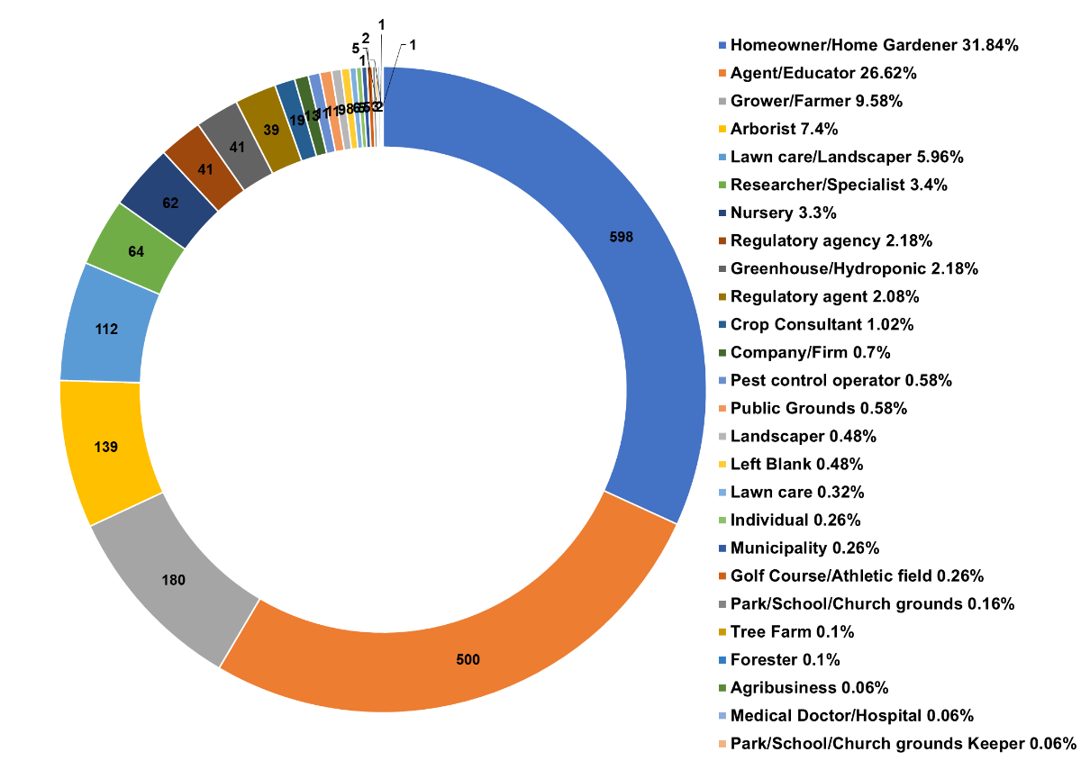

**Fig. 4** PPDC sample counts by client type in 2024

PPDC samples in 2024 belonged to at least 18 categories. More than 40% of samples were woody ornamental plants. We found an increase in submissions of samples seeking insect ID and plant health analyses for small fruits (**Fig. 5**).

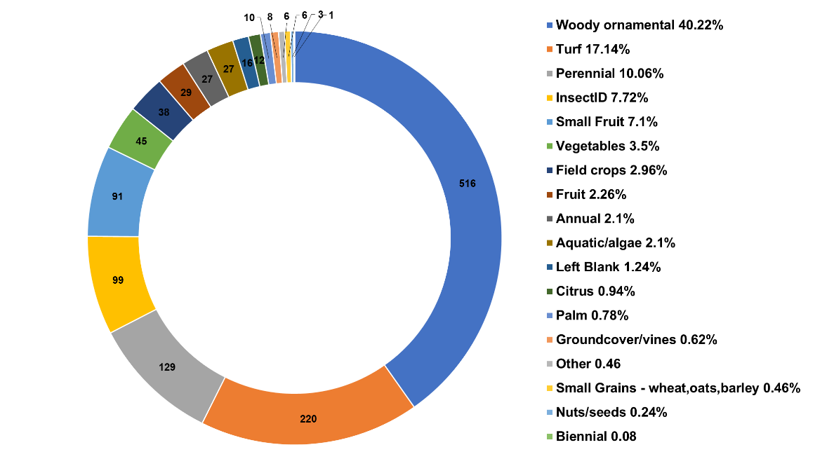

**Fig. 5** PPDC sample counts by sample category in 2024

A total of 1197 samples in 2024 came from 43 SC counties (**Fig. 6**). Other clients were from U.S. states including AL (1), AR (1), GA (3), KS (4), MD (5), ME (1), MO (10), MS (1), NC (18), NY (3), OR (12), TN (15), TX (8), and VA (4).

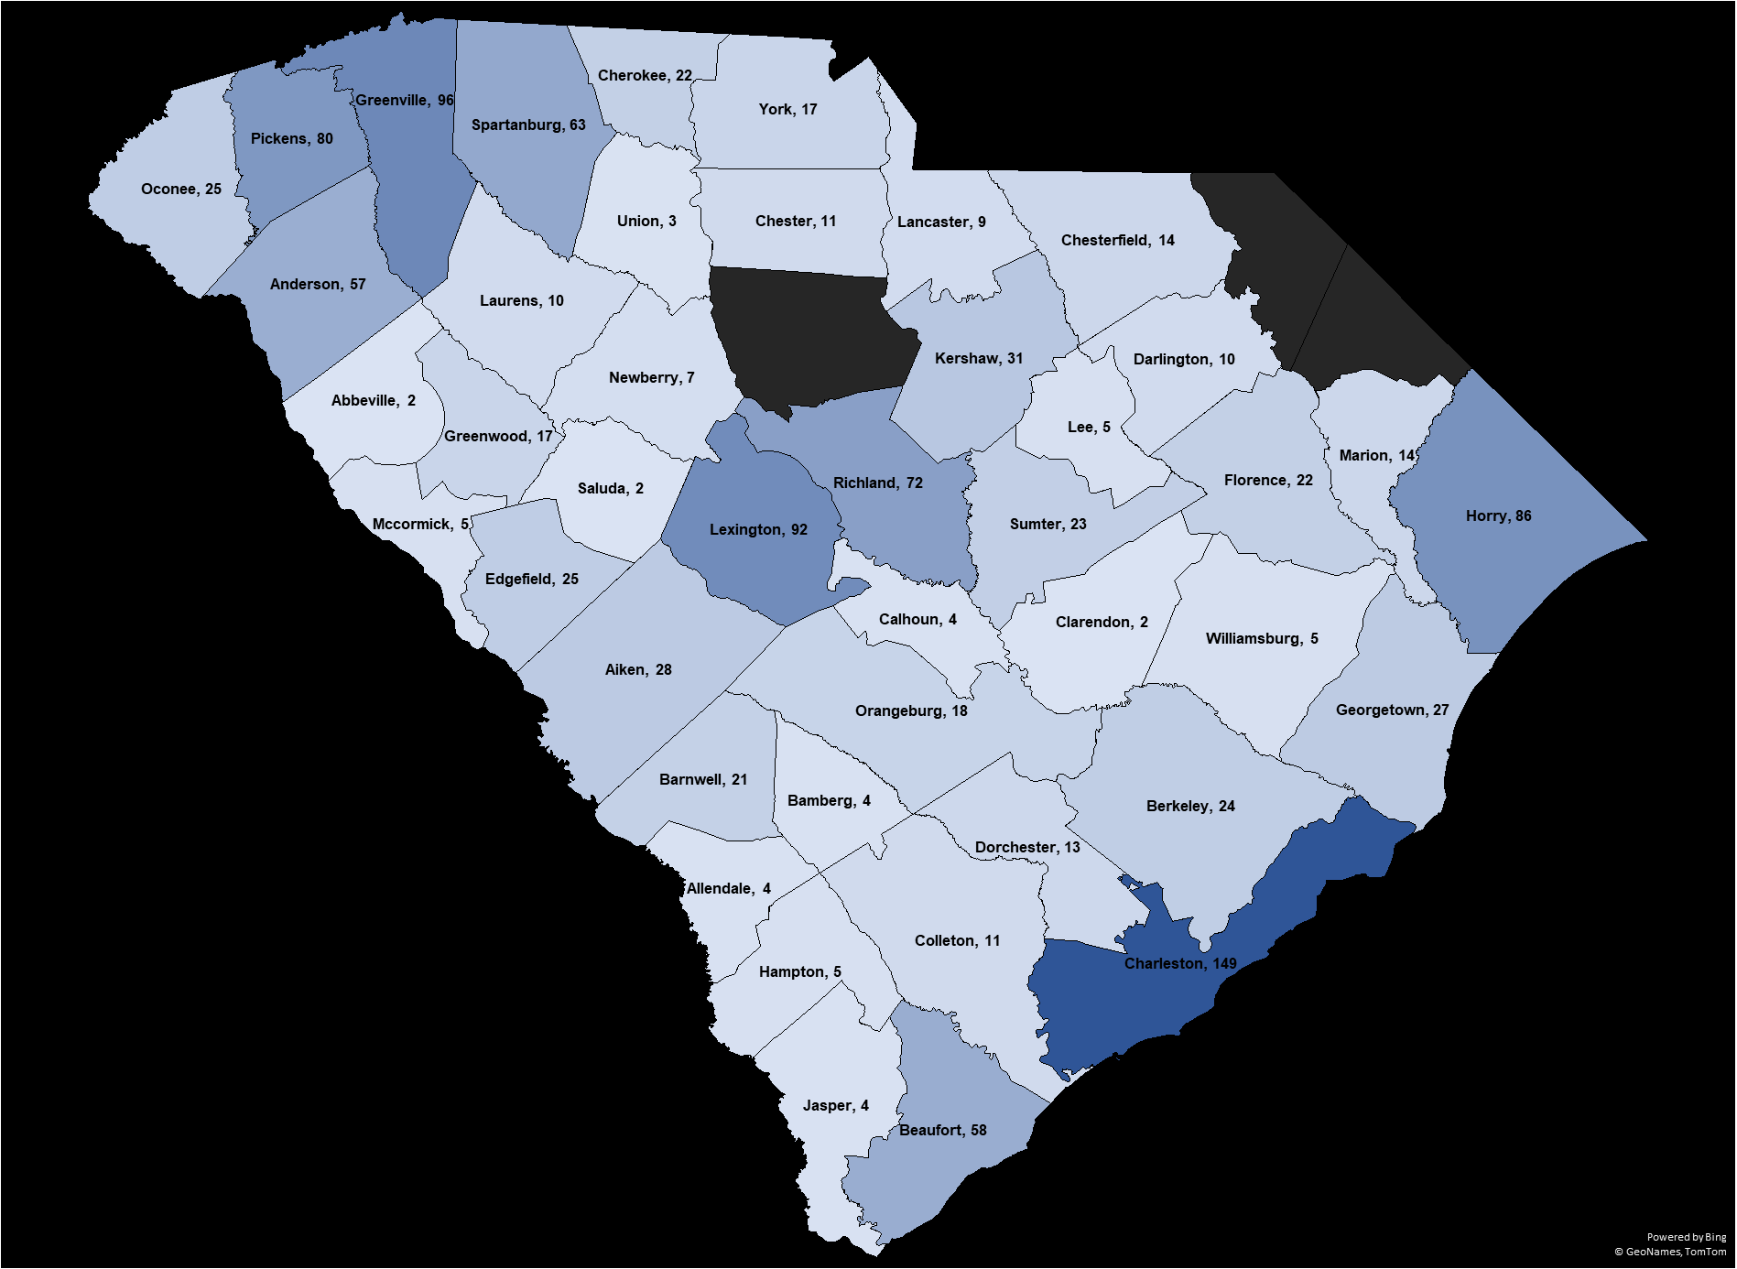

**Fig. 6** Count of PPDC samples in 2024 by county in SC

***Molecular Pathogen and Pest Detection (MPPD) Lab Report***

The MPPD Lab utilizes polymerase chain reaction (PCR)-based assays and other techniques to detect plant pathogens and pests (e.g., Africanized honeybees and two honeybee pathogens, the American foulbrood pathogen *Paenibacillus larvae* and the European foulbrood pathogen *Melissococcus plutonius*). The main targets are plant diseases and pathogens that are of regulatory concern by USDA APHIS and the state of SC, such as the sudden oak death pathogen *Phytophthora ramorum* and the citrus greening pathogens ‘*Candidatus* Liberibacter africanus’, ‘*C*. Liberibacter asiaticus’, and ‘*C*. Liberibacter americanus’. Two staff members (Dr. G. C. Colburn and J. Withycombe) participated in the USDA APHIS PPQ Plant Pathogen Diagnostics Certification Program (PPDCP) and obtained certificates for qPCR, conventional PCR, and ELISA. The MPPD Lab also provides fungicide-resistance testing services for *Botrytis* and *Colletotrichum*. An improved protocol for evaluating Colletotrichum QoI fungicide resistance based on germ tube elongation inhibition was included in a new SOP document (ref. no. CU-PPDC-SOP-02v01).

The MPPD Lab works closely with other Plant Industry survey programs [e.g. Cooperative Agricultural Pest Survey (CAPS)] and provides laboratory testing. In 2024, participated surveys included plum pox virus (PPV; **Table 1**), *Phytophthora ramorum* (*Pram*), citrus greening, yellow-legged hornet, phytoplasma, cogongrass, grapevine moth, spotted lantern fly, and snail surveys.

A total of 1591 samples were processed at the MPPD Lab in 2024. Sample counts by category are listed in **Table 1**.

**Table 1** Sample count by category at the MPPD Lab in 2024

|  |  |
| --- | --- |
| Sample Category | Number of Samples |
| Serological testing | 1501a |
| Molecular ID by DNA sequencing | 26b |
| Fungicide-resistance testing | 16c |
| *Neopestalotiopsis* rapid detection | 15 |
| *Pram* testing | 14 |
| Microbial testing | 10 |
| Foulbrood testing | 5 |
| Citrus greening (Huanglongbing) testing | 3 |
| Africanized honey bee detection | 1 |

a A total of 1500 PPV CAPS samples plus one service sample sought testing for *Xylella fastidiosa*

b A total of 18 fungal, 5 bacterial (including phytoplasma), and 3 oomycete samples

c A total of 14 and 2 samples sought Botrytis and Colletotrichum fungicide-resistance testing, respectively

***Commercial Turfgrass Clinic (CTC) Report***

A total of 17 samples were processed at CTC. Diagnostic results at CTC in 2024 are listed in **Table 2**.

**Table 2** Diagnostic results at CTC in 2024

|  |  |  |  |
| --- | --- | --- | --- |
| Host Name | Pest Name | Confirmed | Suspected |
| Bermudagrass (*Cynodon* sp./spp.) | Noctuid moth (*Agrotis* sp./spp.) | 2 | 0 |
|  | Cereal / grass disease (*Bipolaris* sp./spp.) | 1 | 0 |
|  | Curvularia blight; Leaf spot (*Curvularia* sp./spp.) | 4 | 0 |
|  | Free living nematodes (Multiple genera) | 0 | 3 |
|  | Large patch (*Rhizoctonia solani*) | 3 | 0 |
|  | Pythium blight; Cottony blight (*Pythium* sp./spp.) | 1 | 0 |
|  | Root-knot nematodes (*Meloidogyne* sp./spp.) | 2 | 1 |
|  | Sting nematodes (*Belonolaimus* sp./spp.) | 0 | 2 |
|  | Anthracnose (*Colletotrichum* sp./spp.) | 2 | 0 |
|  | Curvularia blight; Leaf spot (*Curvularia* sp./spp.) | 4 | 0 |
|  | Take-all (*Gaeumannomyces* sp./spp.) | 7 | 0 |
| Zoysia Grass (*Zoysia* sp./spp.) | Large patch (*Rhizoctonia solani*) | 1 | 0 |
|  | Curvularia blight; Leaf spot (*Curvularia* sp./spp.) | 1 | 0 |
|  | Take-all (*Gaeumannomyces* sp./spp.) | 1 | 0 |

***Nematode Assay Lab (NAL) Report***

The NAL was located at the Department of Plant and Environmental Sciences of Clemson University until June 30, 2024. It was relocated in the CAT building at the Regulatory Services in Pendleton as of July 1, 2024. Nematode assay samples are submitted from various sources, including Extension offices, commercial operations, research projects, and regulatory inspectors. In 2024, NAL processed 693 samples including over 50 samples received in each month between March and October (**Fig. 7**).

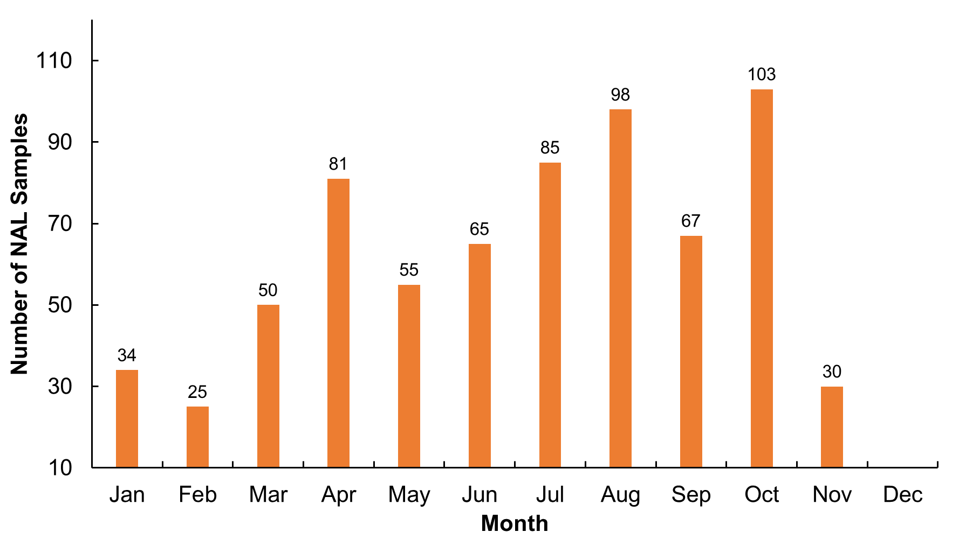

**Fig. 7** Number of samples received at NAL by month in 2024

Most samples received at NAL in 2024 (approx. 95%) were from commercial sources (**Fig. 8**). NAL provided services to 1760 clients in 2024.

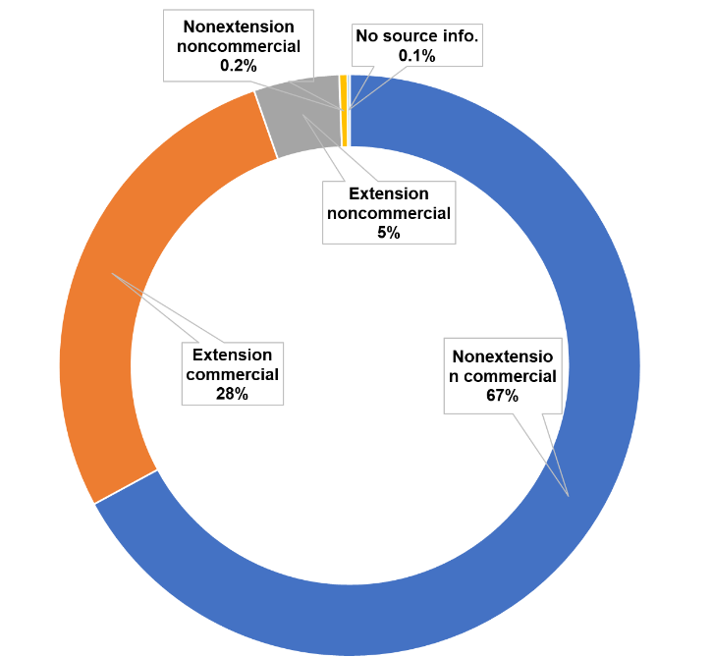

**Fig. 8** Count and Percentage of samples by source at NAL in 2024

More than 43% of the NAL samples originated from turfgrasses, followed by 17% of samples from field crops and 9.4% from small fruits. A total of 439 samples came from 38 counties in SC (**Fig. 9**). Out-of-state clients of NAL in 2024 were from FL (33), GA (15), IL (18), LA (1), MD (2), NC (27), NV (63), and NY (94), plus one sample with unknown state origin.

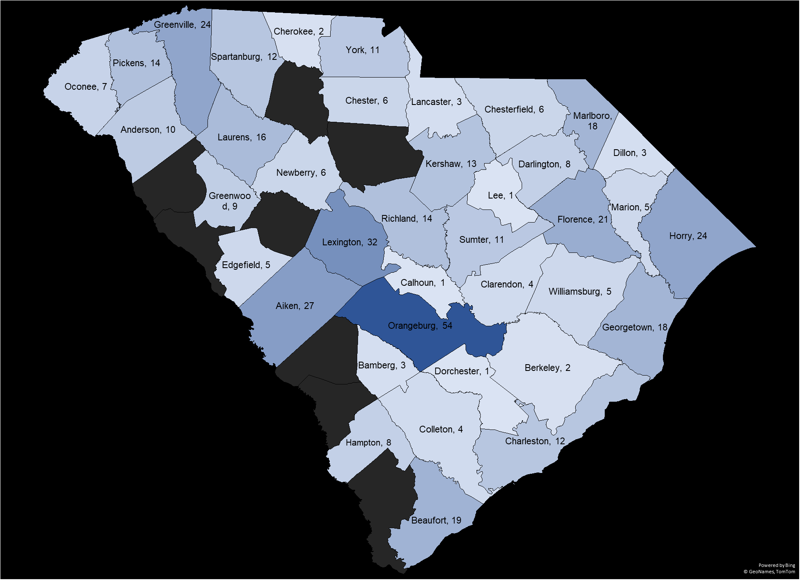

**Fig. 9** Count of NAL samples by SC county in 2024